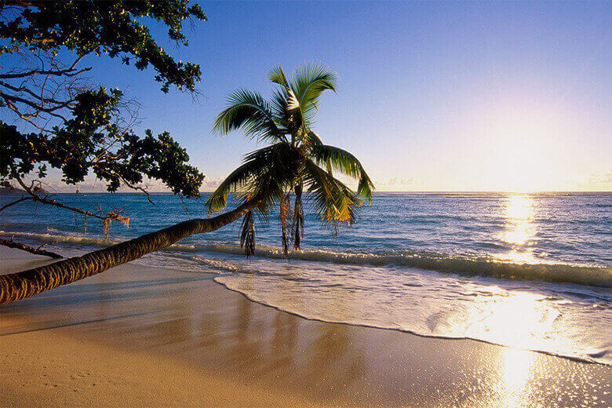

PREETHI KITCHEN APPLIANCES

03 nights /04 days Colombo Group

GROUP SIZE : 40 Passengers

DURATION : 03 night/04 days

PERIOD : Feb – first week

HOTEL Hikkaduwa

PACKAGE TYPE : Premium

Flight Details

UL 168 COKCMB 1535 1650 332 E 0 R
UL 165 CMBCOK 0755 0910 332 E 0 R

ITINERARY

Day 01 : Arrive Colombo

Arrival and transfer to Hikkaduwa En route lunch at a local restaurant, Check in to the hotel and relax
Dinner

Overnight stay at Hikkaduwa Beach Hotel

Day 02 : Hikkaduwa
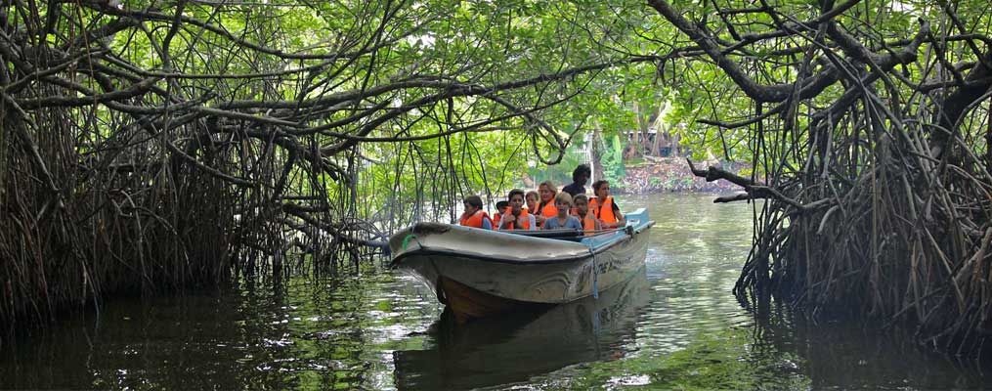
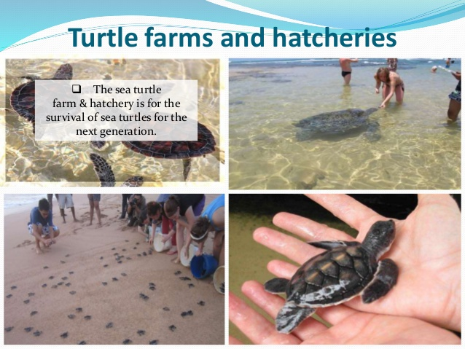

After breakfast proceed to visit a Turtle hatchery and do a boat ride though the Mangroves of Madhu river. Evening take part in water sport activities or spend the rest of the day at leisure ( Optional ) with lunch on the beach Return to the hotel and relax

Dinner & Overnight stay at Hikkaduwa Beach Hotel

Day 03 : Hikkaduwa – Colombo

After breakfast proceed to Colombo Do a city shopping tour of Colombo with Lunch at an Indian Resturant
Evening at leisureDinner at a Indian Restaurant(optional drop at the Casino)

Overnight stay at Z max Hotel Colombo.

Day 04: Departure

After breakfast check out of the hotel and proceed to the Airport for departure flight

-Tour Ends -

Hotel Photographs

Z max Hotel Colombo.
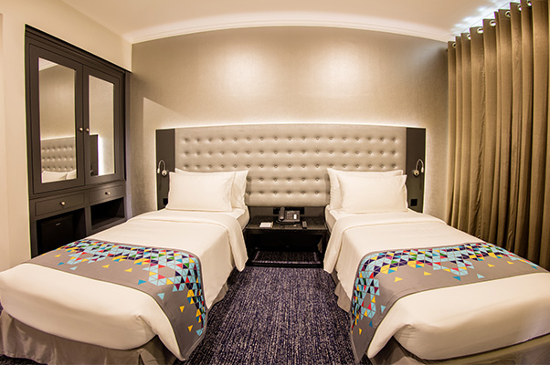
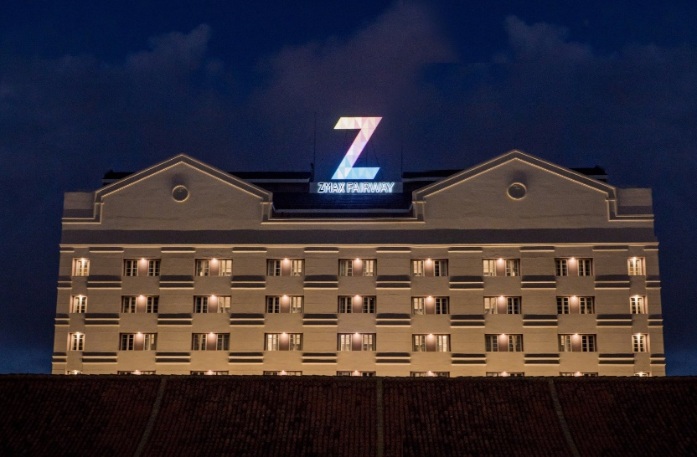

Hikkaduwa Beach resort
