Undertokinq

I, Shri/Smt NISSAM A Undertake the responsibility for operation of this tour Company ANM TOURS AND TRAVELS PRIVATE LIMITED;
HOUSE NO TC 48/963/3, OPPOSITE MILMA, THOTTAM, AMBALATHARA,
M.AN.AC.fiNW PO, Thiru›’ananthapuram. Kerala, 695009
GSTIN: 32AASCA3766A1ZU

For efficient handling of tour operation and bear the damages to life or property of Dislocatlon of environment being the principal agent. I also promse that guidelines for Gpcratior: as circulated by “be Dept. of tourism, Govt. of Kerala from time to tzine will be followed in letter and sprit.

Signature of Proprietor/Partner/Managing Director
ForANMT0U RSRTRAVELSPRNATEL!MlT6D

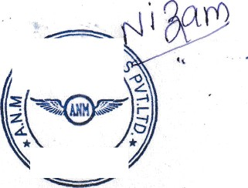Rubber Stamp
Director
4aDR

Place: Thiruvananthapuram

Date: 13/12/2022

