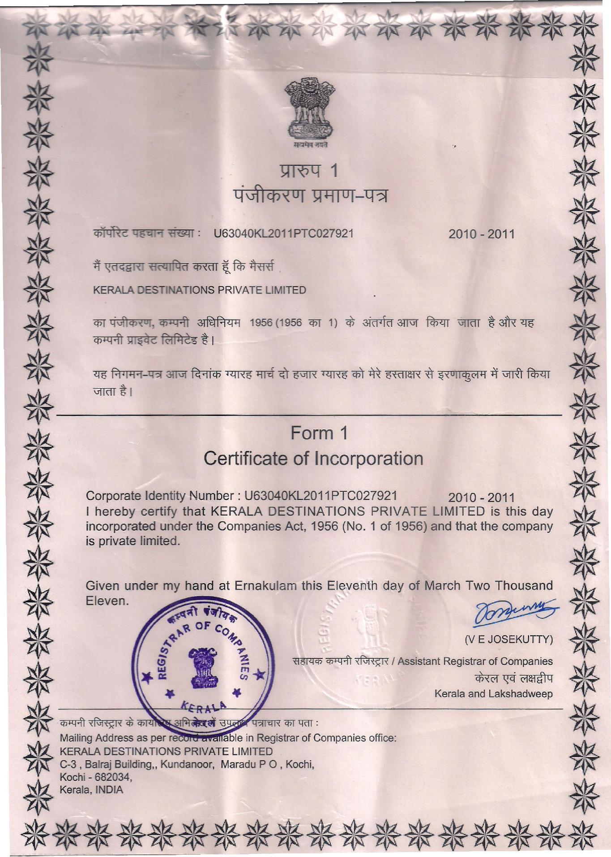
 |  |  |  |  |  |  |  |  |  |  | *t
 |  |  |  |  |  |  |  |  |  |  |  | •••
.•. |  |  |  |  |  |  |  | lm,q 1 |  |  |  | '*
.•. |  |  |  |  |  |  |  | lm,q 1 |  |  |  | *'
.•. |  |  |  |  |  | ~ |  | 1;P:"lIOI-~ |  |  |  | *'
~ |  | ~~~: |  |  |  | U63040KL2011PTC027921 |  |  |  |  | 2010-2011 | •.
.- |  | "if ~d~Ei,< '(ifl1I~d CfffifT t fcp |  |  |  |  | TRRf |  |  |  |  | .-
'* |  | KERMA DESTINATIONS |  |  |  | PRIVATE LIMITED |  |  |  |  | fcn<rr VlTdT 5" 3TR"ll5 | '*
•. |  | cpr q""<t>'<°l. ~ |  |  | ~ |  | 1956 | (1956 cpr 1) | cfi ~ | 3lT\Jf | fcn<rr VlTdT 5" 3TR"ll5 | ~
.- |  | ~~~5"1 |  |  |  |  |  |  |  |  |  | ~
.•• |  | -.;; FwR-'lOI |  | """' | ~ | """" | "'" | <it is!R """" | <!iT'" | ~" | .""'!j~"it UIRt fnm | '*
.•. |  | ~il |  |  |  |  |  |  |  |  |  | '*
*' |  |  |  |  | Certificate:~~~c:rporation |  |  |  |  |  |  | *'
.•. |  | Corporate Identity Number: U63040KL2011PTC027921 |  |  |  |  |  |  |  |  | 2010 - 2011 | '*
*' |  | I hereby | certify that KERALA DESTINATIONS PRIVATE LIMITED is this day ~
 |  | incorporated |  | under the Companies Act, 1956 (No.1 |  |  |  |  |  | of 1956) and that the company |  | *'
. |  |  |  |  |  |  |  |  |  |  |  | ~~
*' |  | is private | limited.
~ |  | ~Ii~~~n~nder my han |  |  |  | at Ernakulam this Eleventh |  |  |  | day of March T~ |  | ~~
~ |  |  |  | ~~"~ |  |  |  |  |  |  | ~'-./' | ~
k |  |  |  | f1 | I ~"""'"-~IAssistantReqistrar of Companies |  |  |  |  |  |  | •
.•• |  |  |  | ...'/,~•• OF |  | C^{O}+... | ~. |  |  |  | (VEJOSEKUTTY) | *
^{*'-}KERALA~.. |  |  | If-~.. |  | .. ""'"'"'" |  |  |  |  |  | Keralaa~:a= | "*
.- |  |  |  |  |  | •.~ * |  |  |  |  | Keralaa~:a= | •
 | Mailing Address as per re |  |  |  |  | able in Registrar of Companies office:
 |  | DESTINATIONS |  |  | PRIVATE LIMITED |  |  |  |  |  |  | .~
*C-3 , Balraj Building" |  |  |  | Kundanoor, |  | Maradu PO, |  | Kochi, |  |  |  | ~~
 | Kochi - 682034 |  |  |  |  |  |  |  |  |  |  | '*
'Kerala, INDIA' |  |  |  |  |  |  |  |  |  |  |  | '*
******************

