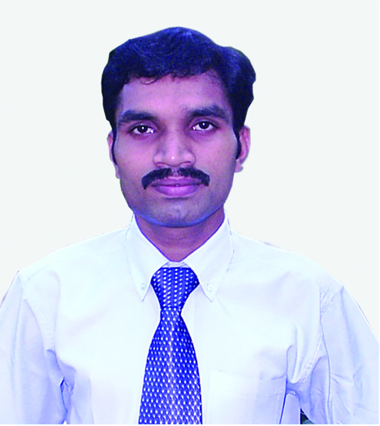
HARIS. P. S
PAMBAKUDACHALIL
PEZHAKKAPPILLY. P.O
MUVATTUPUZH
ERNAKULAM DIST.
PIN: 686674
PH.NO: 0485 2813147
: 09895251398
E-mail: harisps@outlook.com
haarisps@gmail.com

PROFILE

A travel professional who is a POST GRADUATE IN TOURISM ADMINISTRATION.

A knowledgeable and experienced person in the field of travel and tourism. A competent tours coordinator with ample experience.

A person of integrity and commitment with an outgoing and friendly nature. Has a proven track record in excellent Guest handling. Is an expert in handling clients and problems and work well in an emergency

OBJECTIVE:
To work in a high performance environment fostering the idea of team spirit and to be a part of a culture where my skills are utilized to the maximum benefit of the organization.
CAREER EXPERIENCES

2. Presently working in Khaleej Tours, ( Cochin,Kerala, India)
Designation : Operation Manager
Duration : Since Dec. 2014
URL:www.khaleejtours.com

2. Journey Options Holidays, (Kothamangalam, Cochin,Kerala, India)
Designation : Assistant Tour Manager
Duration : 05 years
URL:www.journeyoptions.com

3. Tour Kerala, (Panampilly Nagar, Cochin,Kerala,India)
Designation : Tour Executive (Operation, Costing and Guest Relation)
Duration : Two Years
URL:www.tourkerala.org

4. Creative Tours & Travels, (Muvattupuzha,Cochin,Kerala India).
Designation : Ticketing and counter staff.
Duration : Six Months
URL:www.creative-india.com

EDUCATION

Master of Tourism Administration-2003-2005
H.M Arts and ScienceCollege, Muvattupuzha
Affiliated to MahatmaGandhiUniversity
Secured an aggregate of 66% .

Bachelor of Arts-2000-2003
Private study,
Under MahatmaGandhiUniversity
Secured a course aggregate of 61%

OTHER QUALIFICATION

Computer knowledge:
DTP
Basic knowledge in computer software and hardware.
M S Office : Word, Excel and Powerpoint

PERSONAL DETAILS

Age & Date Of Birth : 36 years, 15th Nov. 1980.
Sex :Male
Nationality : Indian
Religion & Caste :Islam, Muslim
Marital Status : Married

PASSPORT DETAILS

Passport Number : G 5576735
Place of Issue : Cochin
Date of Issue : 29th Oct. 07

LANGUAGES KNOWN
English, Malayalam

INTERESTS
-Travelling
-Listening Music
-Reading books

DECLARATION
I do hereby declare that the information furnished is true to the best of my knowledge and belief.
Place: Muvattupuzha
Date : 03/01/2017

HARIS. P. S

