PrathimaVankadaru
Chartered Accountants
No.66, J P Srinivasam, 17th G Cross, 15th Main Road, Rose Garden Road, J P Nagar 5th Phase,
Bengaluru-560 078 Ph. No.:080-41550174
E-mail: prathimasanjeev@gmail.com

TO WHOM SO EVER IT MAY CONCERN

Cenificate of Chartered Accountant stating Proprietor’s Capital is not less than Rupees Four Lakhs

This is to certify that the capital contribution by NISAR K I, the proprietor of WORLD AIR HOLIDAYS having registered office at 1/278, EDAPPAL ROAD, THRITHALA-679S34 is more than RS. 4, 00,000.00 (Rupees four Lakh only) and the Capital contribution as on 31/03/2023 in the balance sheet is RS.4,74174.74 (Rupees four lakh Seventy Four thousand One hundred and Seventy four and Seventy four paisa only)
We have verified the above facts from the books of account and other records of the institution produced before us and certified that above statement is true and correct to the best of our knowledge and belief

Place : PALAKKAD Date :26-JUL-2023

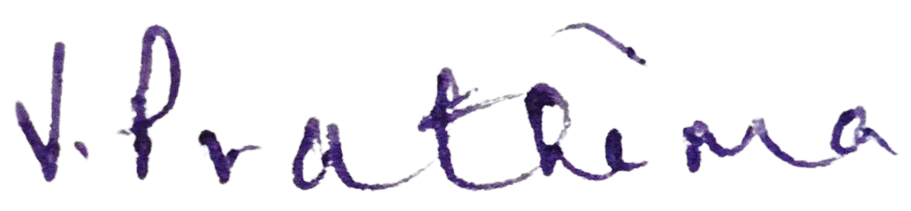

MS. Prathima vankadaru Chartered Accountant Membership No. 224133

1 | P a g e

