PrathimaVankadaru

Chartered Accountants
No.66, J P Srinivasam, 17th G Cross, 15th Main Road, Rose Garden Road, J P Nagar 5th Phase,

Bengaluru-560 078 Ph. No.:080-41550174
E-mail: prathimasanjeev@gmail.com

TO WHOM SO EVER IT MAY CONCERN

Cenificate of Chartered Accountant Showing the Receipts From Tour operation only during the financial year 2022-2023

This is to certify that Mr. NISAR K I, the proprietor of WORLD AIR HOLIDAYS having registered office at 1/278, EDAPPAL ROAD, THRITHALA-679S34 During the financial year 2022-2023 from tour operations only is Rs.5367609.77(Rupees Fifty Three Lakhs Sixty Sevan Thousand Six Hundred and Nine and Seventy Sevan Paisa only)


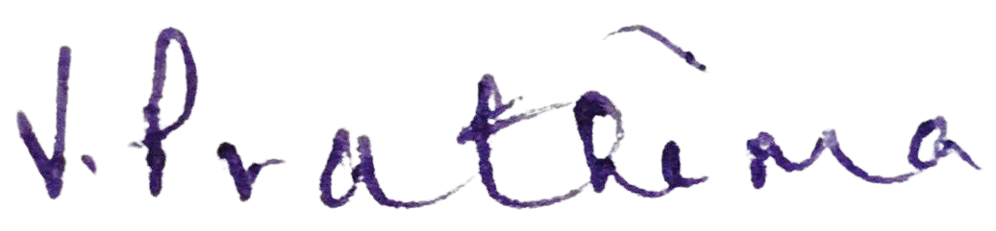
We have verified the above facts from the books of account and other records of the institution produced before us and certified that above statement is true and correct to the best of our knowledge and belief

Place : PALAKKAD Date :26-JUL-2023
MS. Prathima vankadaru Chartered Accountant Membership No. 224133

1 | P a g e

