PrathimaVankadaru
Chartered Accountants
No.66, J P Srinivasam, 17th G Cross, 15th Main Road, Rose Garden Road, J P Nagar 5th Phase,
Bengaluru-560 078 Ph. No.:080-41550174
E-mail: prathimasanjeev@gmail.com

TO WHOM SO EVER IT MAY CONCERN

Cenificate of Chartered Accountant Showing the details of volume of tourist traffic handled up for the financial year 2022-2023

This is to certify that Mr. NISAR K I, the proprietor of WORLD AIR HOLIDAYS having registered office at 1/278, EDAPPAL ROAD, THRITHALA-679S34 During the financial year 2022-2023 from
- Foreign Traffic: 1047500 (Rupees Ten Lakhs Fourty Sevan Thousand Five Hunderd Rupees)
- Internal Tourist Traffic: 4320107.77 (Rupees Fourty Three Lakhs Twenty Thousand One hundred and sevan and Seventy Sevan paisa)

Also Certify that the Receipts of NISAR K I, the proprietor of WORLD AIR HOLIDAYS having registered office at 1/278, EDAPPAL ROAD, THRITHALA-679S34 During the financial year 2022- 2023 From Selling kerala products is Rs.2100500( Rupees Twenty one lakhs five hundred Rupees) Which is greater than 25% (39.13) of total Receipts

We have verified the above facts from the books of account and other records of the institution produced before us and certified that above statement is true and correct to the best of our knowledge and belief

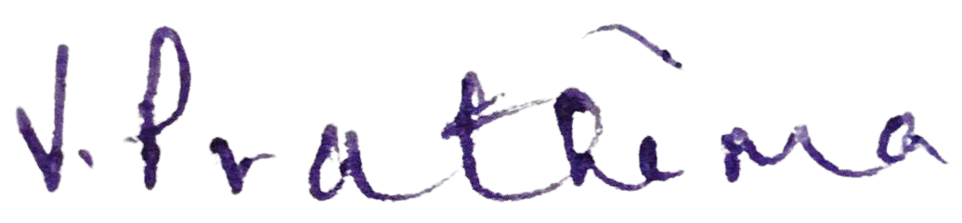

Place : PALAKKAD
Date :26-JUL-2023
MS. Prathima vankadaru Chartered Accountant Membership No. 224133

1 | P a g e

