Acknowledgement Number:858937020220724 Date of filing : 22-Jul-2024

INDIAN INCOME TAX RETURN ACKNOWLEDGEMENT  [Where the data of the Return of Income in Form ITR-1(SAHAJ), ITR-2, ITR-3, ITR-4(SUGAM), ITR-5, ITR-6, ITR-7 filed and verified]  (Please see Rule 12 of the Income-tax Rules, 1962) |  |  |  |  |  |  | Assessment Year  2024-25
PAN |  | BQOPK8547B
Name |  | SAHEER MOHAMMED PARAMBIL KUNHAHAMMED
Address |  | Parambil House, Koottanad Post, Pattambi, Palakkad , PALAKKAD , 16-Kerala, 91- INDIA, 679533
Status |  | Individual | Form Number |  |  | ITR-4
Filed u/s |  | 139(1)-On or before due date | e-Filing Acknowledgement Number |  |  | 858937020220724
Taxable Income and Tax Details | Current Year business loss, if any |  |  | 1 | 0
Taxable Income and Tax Details | Total Income |  |  | 2 | 6,61,430
Taxable Income and Tax Details | Book Profit under MAT, where applicable |  |  | 3 | 0
Taxable Income and Tax Details | 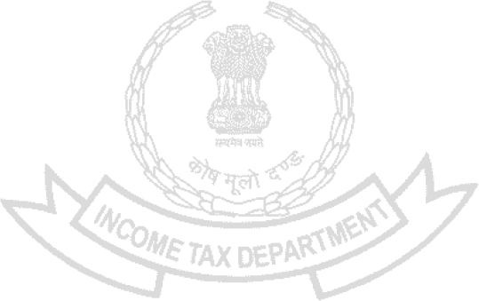  Adjusted Total Income under AMT, where applicable |  |  | 4 | 0
Taxable Income and Tax Details | Net tax payable |  |  | 5 | 0
Taxable Income and Tax Details | Interest and Fee Payable |  |  | 6 | 0
Taxable Income and Tax Details | Total tax, interest and Fee payable |  |  | 7 | 0
Taxable Income and Tax Details | Taxes Paid |  |  | 8 | 33,779
Taxable Income and Tax Details | (+) Tax Payable /(-) Refundable (7-8) |  |  | 9 | (-) 33,780
Accreted Income and Tax Detail | Accreted Income as per section 115TD |  |  | 10 | 0
Accreted Income and Tax Detail | Additional Tax payable u/s 115TD |  |  | 11 | 0
Accreted Income and Tax Detail | Interest payable u/s 115TE |  |  | 12 | 0
Accreted Income and Tax Detail | Additional Tax and interest payable |  |  | 13 | 0
Accreted Income and Tax Detail | Tax and interest paid |  |  | 14 | 0
Accreted Income and Tax Detail | (+) Tax Payable /(-) Refundable (13-14) |  |  | 15 | 0
Income Tax Return electronically transmitted on 22-Jul-2024 16:07:43 from IP address 111.92.67.132 and verified by SAHEER MOHAMMED PARAMBIL KUNHAHAMMED having PAN BQOPK8547B on 22-Jul-2024 using paper ITR-Verification Form /Electronic Verification Code TUX9WM6G2I generated through Aadhaar OTP mode
System Generated Barcode/QR Code

BQOPK8547B048589370202207244b4ea267f96cfa6ff0d37bd51f54d264073a0223
DO NOT SEND THIS ACKNOWLEDGEMENT TO CPC, BENGALURU

