Welcome to God’s own country
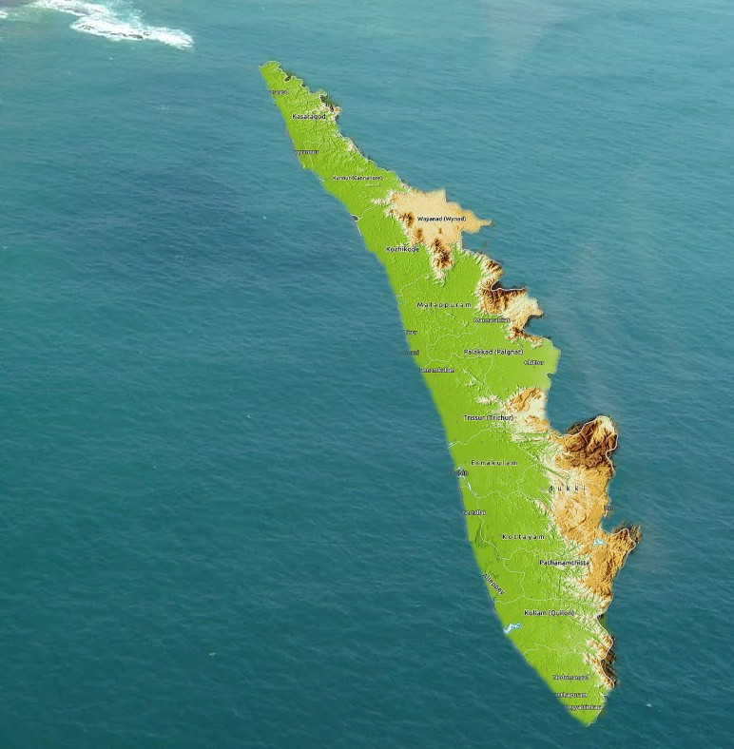
Explore Kerala >
The app consists of a welcome page, interactive imagery & videos, itinerary via airports, railways, road & water transport, etc, different sections for “about Kerala”, “places/destinations to visit”, “police/emergency helpline, guidelines, etc.
__________________________________________________________________________________
First up, the app has a welcome page, titled “welcome to God’s own country” with a famous place & Kerala map as background. There’s an “Explore Kerala >” button at the bottom to see the main app.
It then leads to different dropdown sections mentioned above:
About Kerala, Places/destinations to visit, integrated with maps (with interactive pics & videos and their history/ stories) and “add to itinerary” button; itinerary via air, railway, road & water transport from one place to another, pick & drop services, prices mentioned for different services, holiday packages, specialities (Ayurveda, festivals, houseboats, water sports, hotels to stay in, local cuisines, restaurants, helpline, tourism contact nos., organize lotteries, lucky draws for tourists, the revenue of which goes to Kerala tourism, feedback/recommend via facebook, twitter, etc integrated with the app itself; contests to share photos in Kerala on facebook, twitter pages, etc and win prizes! This would tremendously promote tourism!

