Offline Tourism maps for android application osmand

BINOY B V

1st Year, M-tech Remote Sensing, Anna University Regional Centre, Tirunelveli

binoy9344@gmail.com

Abstract— OsmAnd is a turn by turn navigation application for Android Devices with online/offline features. The project has the aim to make navigation available for all. That's why we are using Open Street Maps data provided by enthusiasts. This application is mostly suited for tourists who want to visit unknown places. They can prepare a map of their own at home and load the map in the mobile and use it while travelling. We can use OsmAnd application online and offline for displaying a lot of online maps, pre-downloaded very compact so called openstreetmap “vector” map-tiles. We can search and find addresses, POI(Places of Interest) routes to navigate with Car, Bike etc. The maps can also be downloaded using a desktop computer. We can also convert our own vector maps in shape file or kml format to osmand obf format.

Key words: Soil, OpenStreetMap, Tile Maps, Vector Maps, OsmAnd, Offline Maps.

- Introduction
Here we discusses about creating offline maps for Android application. The OSMAND application is one of the few applications which use vector maps in mobile. The binary file format used by the OSMAND takes only less memory size as compared to maps used in Desktop. The OSMAND can display free maps from OSM, hence OSM is discussed in the initial part. The later part discusses about OSMAND and the creation of .obf file from other formats.

- Openstreetmap (osm)
The OSM project creates and distributes free geographic data of the world. Most maps we think as free has legal and technical restrictions on their use. For example we cannot download vector maps for offline usage from Google Maps or Yahoo Maps. But in OpenStreetMap we can download vector data for free. OpenStreetMap is open data, licensed under the Open Data Commons Open Database License (ODbL). The site is supported by the OpenStreetMap Foundation, a non-profit organization registered in England. We are free to copy, distribute, transmit and adapt our data, as long as we credit OpenStreetMap and its contributors. If we alter or build upon OSM data, we may distribute the result only under the same license.
We can also update the OpenStreetMap using tools like Potlatch-2, Merkaartor, JOSM etc. OpenStreetMap is updated by users all around the Globe. Since OSM is free we download and use the OSM data in Mobile Maps (OsmAnd).

OSM Binary Format
OSM Binary format is intended to replace the xml format commonly used for the distribution of OSM data. These binary formats can be used in mobile devices because they contain only less memory. The most commonly used binary formats in OSM are .pbf and OSM.bz2. These formats can be easily converted into OsmAnd .obf file format using OsmAndMapTileCreator. OsmAnd is an application which displays binary maps and does other functions such as rendering and routing.
The features of OSM Binary Formats are,
- Less storage space
- Indexed access into the file without loading the complete file into memory.
- No floating point.
- Large map can be saved as a group of smaller maps each covering a well defined area (Tiles).
- Read-only format.
Uses of OSM Binary formats are,
- Display the map with different information.
- Zoom the map.
- Pan the map.
- Find position on the map based on GPS.
- Find position based on Street Address and POI.
- Identify an object on the map based on user click.
- Find a route for a fixed vehicle-type from one way to another.

- Raster & vector maps in mobile
In mobile devices two types of maps are available.
- Tile Maps
- Vector Maps
Tile Maps are raster maps like pictures. They are created on a server and downloaded as tiles to our device. After zooming to a particular extend pixels will become visible. OSM Maps, Google Maps are all tile maps that can be displayed on mobile devices. Tile Maps works in the same principle as in a desktop browser. A request is send from the device to the remote server. The server receives the request and sends back the tile images in the queried latitude longitude areas. Usually the images are send as png files. Based on the zoom level requested the server will send separate image tiles.
When we see a vector line, the co-ordinates of the line are stored in the database. We can decide and change the color, thickness and other attributes of such lines. In mobile devices all objects are “painted” or “rendered” on the fly. We can see the objects being drawn on the screen. OsmAnd is one of the very few Android applications which support vector maps. The advantage of vector maps is that we can store the vector file in phone memory or memory card. By zooming in we can see a lot of details without storing gigabytes of maptiles as in Tile Maps.

- Osmand
We can use OsmAnd application online and offline for displaying a lot of online maps, pre-downloaded very compact so called openstreetmap “vector” map-tiles. We can search and find addresses, POI(Places of Interest) routes to navigate with Car, Bike etc. We can also share our position with friends by mail or sms text-messages. OsmAnd can be freely downloaded in Android devices using Google Play.
If we had a good online connection, there is little need to prepare offline data. In online data the features available will be Auto-Zoom, Rotating Map, Choose map source, Find Addresses, Routing etc. Some features will not be available like viewing POI over maps and seeing preloaded map tiles. If we need these features we need to download offline data.
The options available for downloading offline data are
- Download data through application from Internet Tile sources as Google Maps, OSM, Bing Maps, Bicycle Maps.
- Download vector data from the application itself.
- Create map tiles using OsmAndMapTileCreator.
- Download free obf files of OpenStreetMap data from the website http://download.osmand.net/rawindexes/
Downloading Offline Maps
Both Raster Maps and Vector Maps can be acquired by using the application. The maps can also be downloaded using a desktop computer. The OsmAnd application has both free version and paid version. In the paid version we can download unlimited no of obf files using the application. In the free version of OsmAnd we can download only a few number of obf files using the application. Also we need a high speed internet connection to download large files if we are downloading the obf files through mobile phone.
- Tiles are usually bitmap images and can be downloaded from open sources such as Google Maps or OSM.
- We can download Tiles within the Android device itself. We can Zoom in to an area and download tiles for each different zoom levels.
- Second method is through use of OsmAndMapCreator. In this method we download the Bitmap images in computer and create an sqlite database. Then we put the sqlite database under /osmand/tiles in memory card.
- We can also download vector maps. They have very compact size and high zoom levels are possible
- We can download vector maps directly using the application.
- We can create our own obf files using OsmAndMapCreator. After creating obf files we put these into osmand folder on phone. The creation of obf files from shape files is demonstrated in a seperate section.

OsmAnd Applications
- To visit an unknown Town as tourist without internet connection.
- Search Places, Lakes, house etc
- An OSM contributor can open/create OSM bugs, edit POI etc.
- We can navigate to a point by specifying Latitude/Longitude values and save the track.
- We can save our favorite points and search our closest POI.
- By activating GPS or Network Positioning we can obtain our location information in OsmAnd map.
- We can create our own application using OsmAnd for our specific purpose. We can alter the code since this application is free.
- OsmAnd can also be used in tablet Computers having Andoid Operating system and also a version for Blackbery OS is also available.

Results and discussion

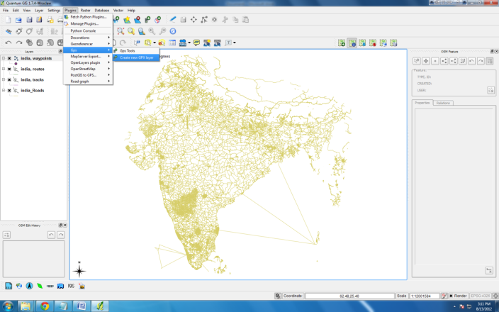

Fig. 1 Create GPX File (QGIS)

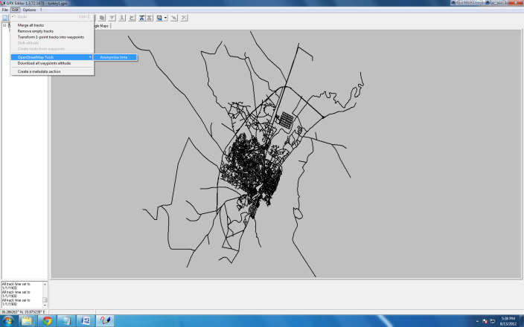

Fig. 2 Editing Timestamps of GPX data

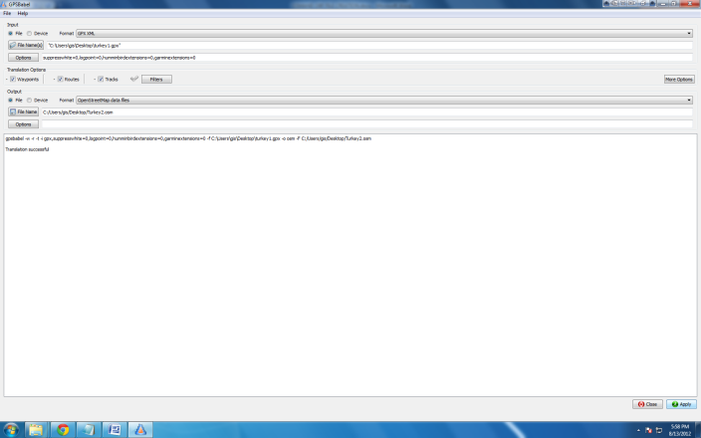

Fig. 3 Converting GPX file to OSM data

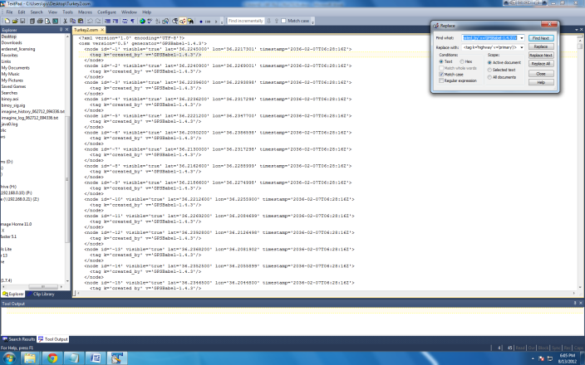

Fig. 4 Editing OSM in Text Editor

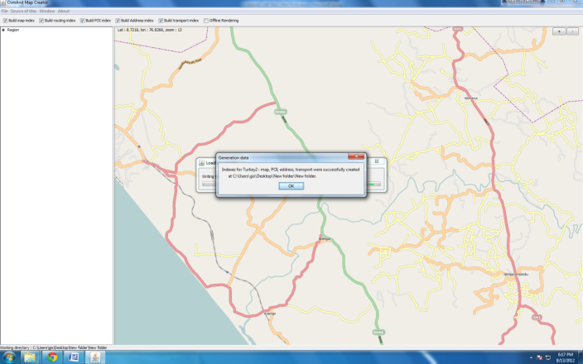

Fig. 5 OBF file Creation (Osmand Map Creator)

- Conclusion
OsmAnd is a very useful application in the field of mobile GIS. The future of GIS lies in new age technologies like web mapping and Mobile GIS. The real time tracking using mobile and routing are applications which are going to expand the horizon of GIS.

- References
[1] http://osmand.net/

[2] http://download.osmand.net/rawindexes/

[3] http://wiki.openstreetmap.org/wiki/Main_Page

[4] http://wiki.openstreetmap.org/wiki/OsmAnd

[5] https://github.com/osmandapp/Osmand

