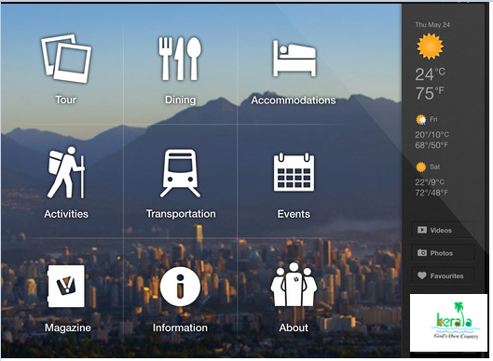

The app should be simple and still give clue for all information required, therefore for a traveler to kerala should be aware of all the basic requirements like below:

- How to arrive
- Where to stay
- Find the food
- What are activities
- Places to see
- Events in Town
- Any cultural events happening in town
- Information on Town ( Weather , videos, Photos)
- Share the information on Social network – so that it gets promoted and his/her friends find interesting to visit the place.

