Dream to Kerala
Dream to Kerala this app helps you to organize and plan your tour to Kerala. You can create a trip for your next vacation in couple of minutes arranging the places selecting the spot using Drag and Drop feature help user to easily organize the plan.
This app discovers new places through Google Map and geo - location which is powerful and useful for the travellers. Here we are implementing augmented reality to show the info about the places.
The following are the ideas
- Discover Kerala (Feature 1)
- Name the trip
- Choose the place to visit, Group and order information using drag and drop
- Know which place is best to visit
- On selecting the place the route to that place will be shown in the trip created.
- The best hotel, lowest cost cab all will be shown according to the place which we select.
- Augmented reality
- location based augmented reality (sample images shown below )
- showing the mobile camera to any place in the tourist spot will show the following details to the user
  - History of that place.ie the tourist spot. (Feature 2)
  - Option to translate the information in any language. (Feature 3)
  - Virtual tour to Kerala museum, places so that user can have an idea of how the place would be before spending the time money. (Feature 4)
Benefit Kerala Tourism:
- In app purchase i.e. the app will release with the beta version, so if the user needs features other than feature 1. He needs to purchase the feature one by one.
- According to the complexity Kerala tourism will fix the rate for every added feature. The user will have to purchase the feature.
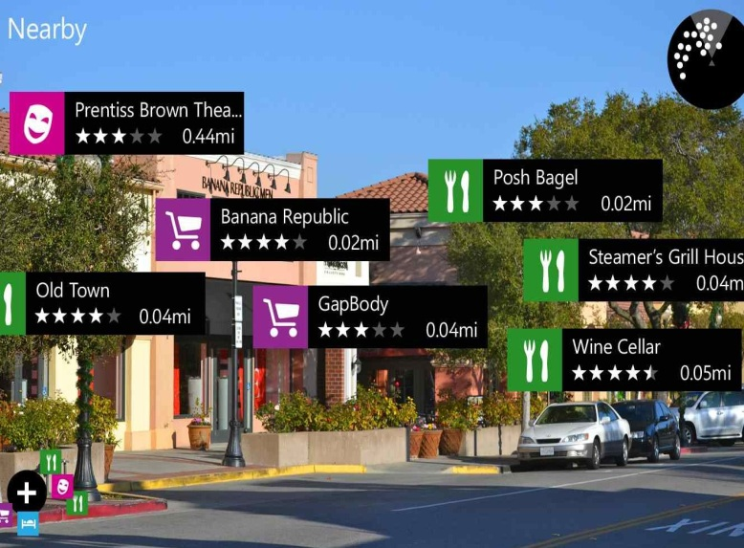
- All trip details are stored in clouds so you can synchronize in any devices.

