When tourist user click on the Kerala tourism application icon then display Kerala state map all the major tourist destinations in  Kerala, including connected distance K.m. Between to each other tourist destination on the map. With tourist city name highlighted icon according to their categories like historical, hill station, sea beaches,religious,National parks and health center .These are describe in image which is not on exact scale map and distance between cities, it’s only for help of describing this paragraph. | 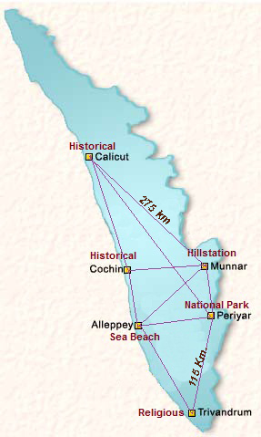
After then user click on particular tourist destination city it will show all the tourist attraction in the city and nearby attraction of the city with sight scene name small description and photo gallery slide show including distance map from center hub to the tourist city to nearby sight scene. The tourist city also give some more option to the user like shopping attraction in city, Hotels and Local taxi tour operator’s name and contact number. Tourist can write user review for visited sight scene.
Slide show with arrow buttons all sight scenes in Thiruvananthapuram and nearby.
Thiruvananthapuram
Sri. Padmanabhaswamy Temple
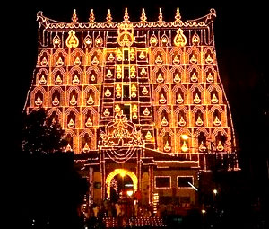
The 16th century shrine of Lord Vishnu as Sri. Padmanabhaswamy
Distance map nearby local attraction
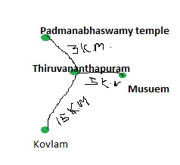

Thiruvananthapuram
Jaipur | 3000 K.m.
Delhi | 3300

Application footer Hotels,shopping,taxi tour operator name with contact and list of other state capital cities distance from Thiruvananthapuram.

