KOKO-Kerala

The first thing that comes into mind when we heard about kerala is coconuts and water bodies. So I suggest the name of app as KOKO –Kerala. The basic design of the app is as follows. The home screen of the app is designed as shown in figure 1.
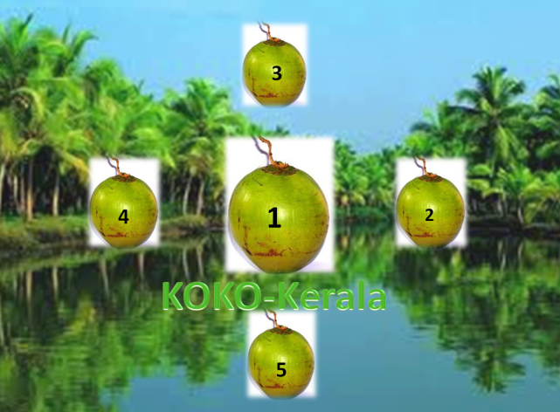
Figure 1
This window consists of 5 sub-windows marked 1 to 5.
When the user selects coconut numbered 1 “we will play a video showing the tourism spots in kerala”.
When the user selects the coconut numbered 2 “we display all the locations that a tourist needs to visit in Kerala, we will also show their opening hours, distance from railway station, airport and bus stand etc.”
When the user selects the coconut numbered 3 “we will display all the transport services that are available for the tourist spot like bus service, call taxi, autos etc. We also give the price and distances. We can also provide details of tourist services in Kerala”.
When the user selects coconut numbered 4 “we will show some HD wallpapers and which can be downloadable by the users”. This is like extra benefit we are providing them.
When the user selects the coconut numbered 5 “we will give some live wallpapers of tourism spots in Kerala, which can be downloadable”.
We are providing some extra benefit to our users by allowing them to download all the pictures and live wallpapers. We can add one more coconut on the shopping areas in Kerala and the products that we can find In Kerala.

