I have name my idea as application would be called as GO TO KERALA (GTK).
Following are some steps which can help in both ways in tourism and in revenue:
Cheap, high-speed broadband is the rule here rather than the exception.

Now, the features should be there:
1:If we can put their smart phone’s GPS function to good use, the visitor will be not only be constantly updated on nearby points of interest, accommodation, dining options, weather, currency rates with the newly-released (For Example)version 1.0, users can now simply point their camera at the surrounding area and by using GO TO KERALA (GTK)application. Augmented Reality feature (Augmented reality (AR) is a live, copy, view of a physical, real-world environment whose elements are augmented (or supplemented) by computer-generated sensory input such as sound, video, graphics or GPS data.) and it will quickly fill in the details, overlaying icons Google Street view style as shown below:
Sample on Augmented Reality Screen
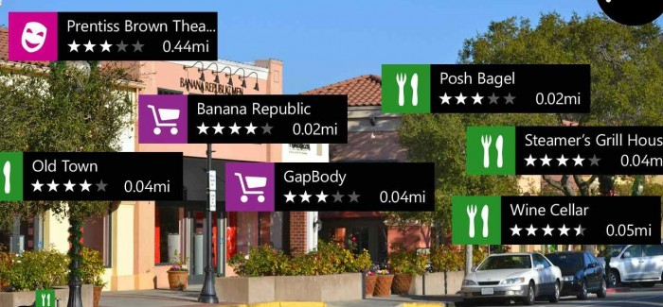

2:We can also make a card system like (e.g:EasyMoney) - rechargeable cards available from airports, stations and all bus stations and convenience stores that circumvent the need for loose change, and which can be used not only to pay transport fares, but also for goods in convenience stores and an increasing array of other retail venues.
Sample Loose Money Card
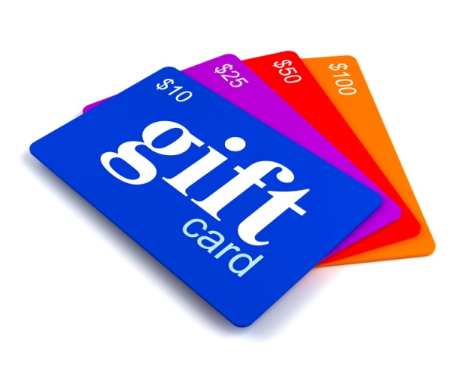

3: Similar if we can use the concept of multilingual clarity on stations and other tourist destinations, where stations are equipped with touch-sensitive Google Earth-like maps, ensuring that even when the visitor finds themselves in a station with more exits than a freeway, they will know precisely which one to choose.
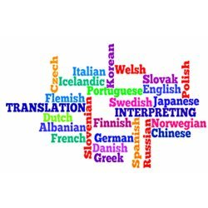
Multilingual Environment
4: Major bus stops should be equipped with LED displays supplying the traveler with ETAs (Estimated time for arrival), the routes for which are mapped out quite literally on the Plexiglas shelters. Appearing beside the route information, new Quick Response (QR) codes, designed to be scanned into the smart phone, display real-time bus information and a wealth of other key transport data in the language of their choice as shown in below:
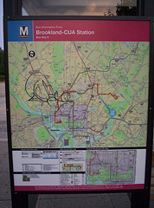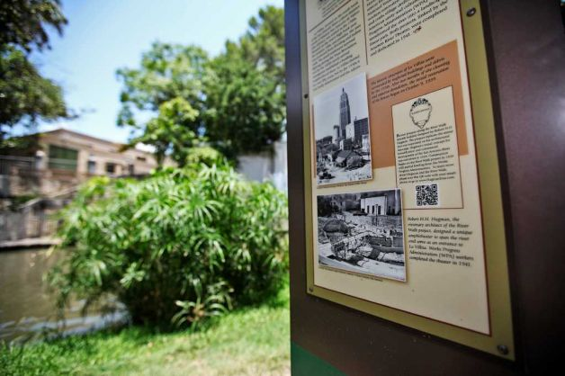
QR-Smart phones can easily access the
Information of the respective content by QR reader.
LED DISPLAY SAMPLE ON PLEXIGLAS

