CHAPTER 1

Introduction, Objectives & Application

1. In the exercise of the powers conferred by section 5 (1) (i) of the Kerala Tourism (Conservation and Preservation of Areas) Ordinance 2005, issued in Notification No.500/Leg.A1/2005/Law Dated 11-01-2005 and published in Kerala Gazette, the Tourism Conservation and Preservation Committee, constituted by Government of Kerala, here by make the following guidelines for conservation and preservation of special tourism zone, Kovalam.

2. Short Title, Extent and Commencement

- These guidelines will be known as the Regulation for Developments in the Special Tourism Zones- Kovalam
- These shall apply in the designated area under the special tourism zone – Kovalam.
- These guidelines will come into force with immediate effect.
- These guidelines will have overriding effect on all the existing regulations pertaining to the subject concerned.

3. Objectives

  - The beaches of Kovalam have emerged as one of the popular tourist destinations of the country. The environmental quality of this fragile natural area, although ad-hoc in nature, have started degrading in recent years due to unprecedented growth in tourism. The sustenance of tourism development in this area will depend on careful planning and management without hampering environmental and socio-cultural and elements.
  - The Government of Kerala have promulgated an ordinance for the conservation and preservation of tourist areas in the state and notified in extra ordinary gazette dated Jan-11-2005. The following guidelines are prepared for conservation and preservation of the Special Tourism Zone. It will be mandatory that all developmental activities in the Special Tourism Zone will be regulated according to these guidelines.
  - The detailed objectives are:

    - To control and guide all developmental activities in the notified area of the Special Tourism Zone.
    - To tailor tourism development to conform to the unique characteristics and the natural attraction of the destination.
    - To ensure the conservation and preservation of its environmental value.
    - To draw specific norms for each zone to ensure that a fine balance of economic, social and environmental preservation is achieved.

4. Application

These guidelines are applicable to Special Tourism Zone, Kovalam and shall apply to:

(a) Any public or private building as described below, namely: -

- Where a building is newly erected, it shall be applicable to the designs and construction of the building.
- Where the building is altered, it shall be applicable to the altered portion of the building,
- Where the occupancy or the use of a building is changed, it shall be applicable to all parts of the building affected by the change,
- Where addition or extension is made to a building, it shall be applicable to the addition or extension only, but for calculation of floor area ratio and coverage permissible and for calculating the required off street parking area to be provided, the whole building (existing and the proposed) shall be taken into account:

(b) All lands proposed to be developed or redeveloped for construction of buildings,

(c) All the land development and constructions existing or proposed in any village / panchayath area to which the provisions of these rules stand extended.

(d) Quality standards for:
(i) Restaurants
(ii) Ayurveda Centers
(iii) House Boats

(e) Until special Land Use Zoning Regulations for areas under tourism promotion or for any other propose are promulgated, the land use category as indicated in the Master Plan prepared for Special Tourism Zone Kovalam along with the corresponding Land Use Zoning Regulations shall continue to remain in force.

(f) For any building construction or land development for tourism promotion as per Zoning Regulations of the master plan, it is mandatory to obtain specific clearance from Tourism Conservation and Preservation Committee, Kovalam, before taking up such developments or re-development

5. The definitions of terminologies appearing in these guidelines are amplified as definitions at Appendix A attached.

6. Area, Extent and Delineation -The potential tourism regions around Kovalam comprising parts of Trivandrum City Corporation and Grama Panchayaths of Vizhinjam, Thiruvallam, Venganoor and Kottukal and Poovar are delineated as Special Tourism Zone, Kovalam. Certain surrounding facilitating nodes like Venganoor, Thiruvallam, Pachaloor, Vellar, Pulinkudi and Mukkola, are considered. The area encompasses a 13 Km coastal stretch from Edayar island to Poovar. (Sketch attached)
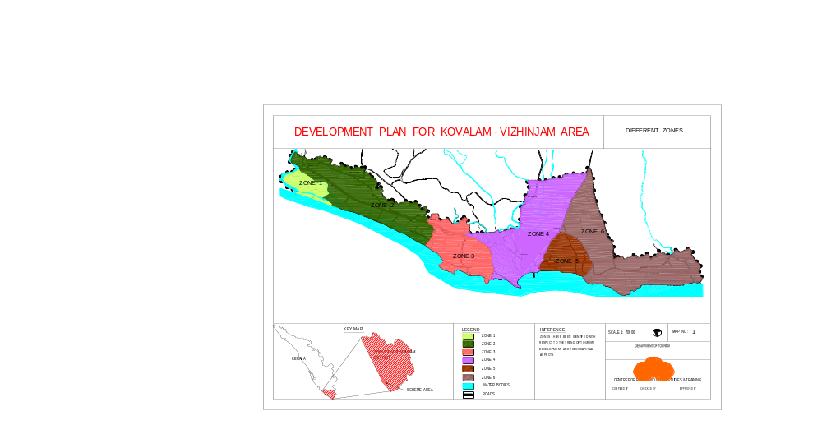

(a) Areas. The Special Tourism Zone area is a linear stretch of coastal land 1-3
Km wide. The area is categorised into six distinct zones each having
individual environmental characteristics with diverse tourism potential as
specified under: -

i). Zone 1. (Edayar Island). This area is sparsly populated. The typical island ecosystem is degraded due to sand mining and non-eco friendly human interventions. The access to the island is through a footbridge.

ii). Zone 2. (Thiruvallam Area). The area extends along the seacoast from Pachalloore to Vellar between the NH bypass (Kazhakuttam – Parassala) and the seacoast. Uncontrolled retting of coconut husk and reclamation of the water body has substantially altered the landform

iii). Zone 3. (Howah/ Eve Beach Area). This is the current core tourism area of Kovalam extending from the Vellar KTDC Complex to Vizhinjam lighthouse, with its sandy shallow beaches and saturated with construction activities.

iv). Zone 4. (Vizhinjam Harbour). The area extents from lighthouse to Vizhinjam fishing harbor. This large settlement colony of local fisher folks is naturally congested.

v). Zone 5. (Muloor Area). The area with its unique undulating hills and valleys extends from Vizhinjam harbour to Muloor.

vi). Zone 6. (Pulinkudy Area). The zone extends from Muloor to Adimalathura, 4.5 km long approximately. The characteristic features of the area are the interspersed over hanging rocky hills, encased beaches, valleys, laterite cliffs and coconut groves. The shallow beaches with protrusions to the sea forming isolated beaches are one of the major attractions of the zone.

vii). Zone 7. (Poovar Area)

(b). Boundaries of the Special Tourism Zone

North: Karamana River running West of Thiruvallam village
and Edayar Island.
West: Arabian Sea.
East: Poovar – Uchakada road on the South East up to Uchakkada Junction.
South: Road from Uchakkada Junction up to Pulikudi Junction.

(c). Extent

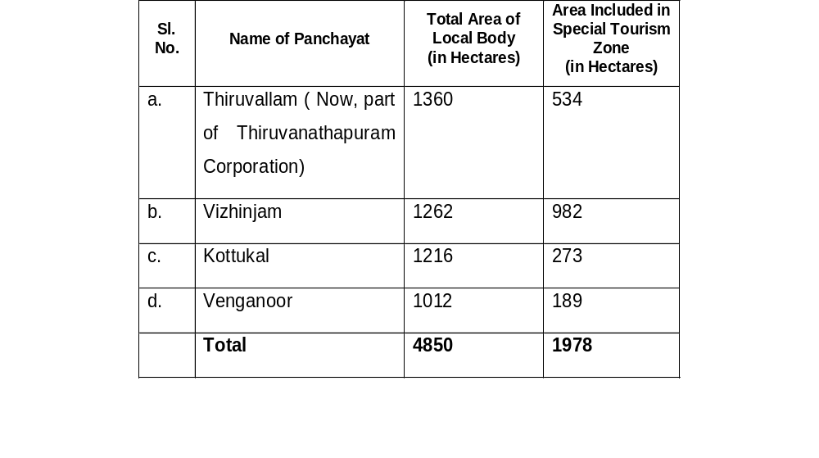
CHAPTER 2

Guiding Principles & Developmental Policies

7. Guiding Principles of these Guidelines –

(a) These Guidelines address specific developmental issues, which have impact on environmental and scenic values of the tourist destination. For example; visual impact (eg. natural elements of aesthetic value), odour (sewage treatment), emission of noise (e.g. power generation, vehicles and boats), pollution (smoke, dust, solid and liquid waste).

(b) Conserving the community’s natural resources, so that ecological processes including interconnected physical and biological systems, on which life depends, are maintained and the total quality of life, now and in the future, are enhanced, attracting sustainable tourism to the destination.

(c). Preventing the ad-hoc and unplanned developments, eroding the scenic and environmental values of the area, over time.

8. Developmental Policies in The Special Tourism Zone –

(a) The guidelines are framed zone wise based on policies for sustainable tourism developments, considering the landforms, character of settlements, type of prevailing tourism development, quality of beaches and their degree of degradation.

(b) A major portion of the area covered under the Coastal Regulation Zone (CRZ), notified by the Ministry of Environment and Forest, Government of India. While carrying out developmental activities related to tourism, care must be taken not to destroy the quality of natural resources which the tourists come to enjoy. The facilities created should not physically alter or have a negative visual impact on the existing natural environment or system.

(c) All tourism infrastructures envisaged for the future, within 500 m High Tide Line (HTL) from the sea coast would be small scale, low impact and high quality developments. The aim is to retain the scheme area in its original ambience and scenic beauty by tailoring the physical developments to be synchronized with conservation and preservation of natural resources.

(d) In areas which are predominantly occupied by residential settlement and mixed with agricultural uses, the trend should continue and no specific controls will be insisted upon in these areas.

(e) All tourism related infrastructure and development programmes, except in the
island area, will have motorable access.

(f) All development sites will have infrastructure facilities for protected water supply, drainage, electricity, solid waste disposal mechanism, and sewage control methods.

(g) All developmental sites should have stable ground conditions.

(h) Building or infrastructure should not be subjected to inundation.

CHAPTER 3

Guideline for Development Promotion

9. Guidelines for Development Promotion in Different Zones -

Land use plan prepared by the Department of Town and Country Planning Department under the master plan for Special Tourism Zone- Kovalam is shown as map indicating various development zones.

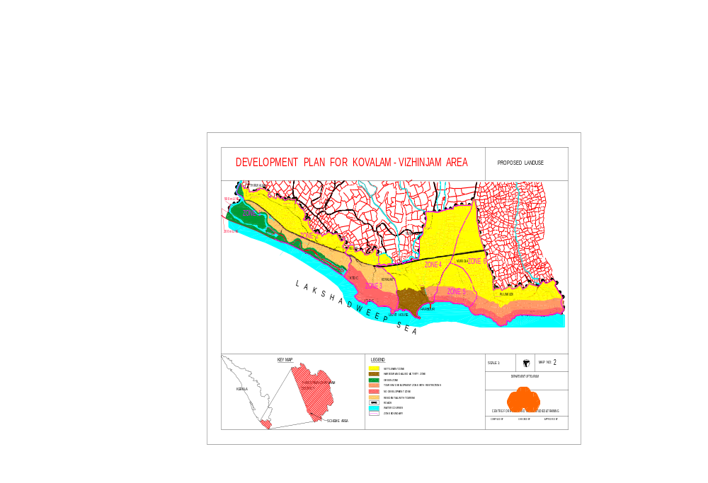

The implementation measures are amplified below:

- These guidelines will supplement further and guide the granting / refusal of permission for any development in the Special Tourism Zone.
- The following proposed land use zones under which detailed regulations are formulated :

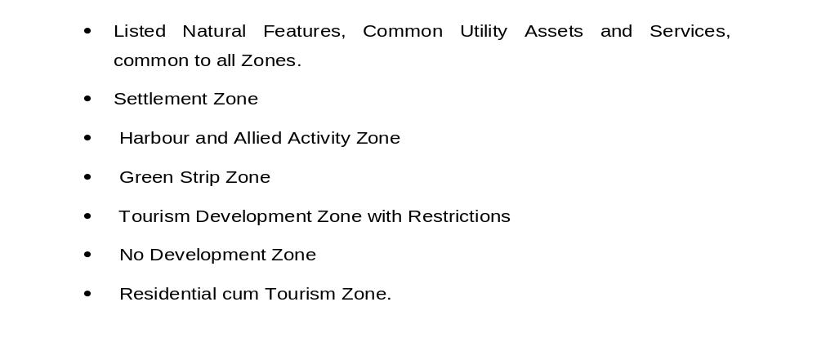

- Uses permitted Restricted and Prohibited in different categories of land use zones are described in the zoning regulation of Master Plan.
- Non-conforming use. If any portion of a zone is put to “Use Prohibited” category before the sanctioning of this regulation, such use will be termed as “Non conforming”. A non-conforming use will be allowed to continue in its existing location for a specified period of 5 years, depending on its environmental influence. Before the expiry of this specified period, the non-confirming use shall be shifted from those premises
- Existing areas and structures of archeological importance, existing agricultural tracts, burial ground, religious buildings, roads, utilities and services incidental to the main use may be permitted in all zones and will not constitute a non conforming use.
- Other Controls: Government may in any particular case on the recommendation of, Tourism Conservation and Preservation Committee and subject to any condition as they may impose, dispense with or modify any of the requirements of the scheme other than the requirement made obligatory by any law and their decision shall be final.

10. Listed Natural Features, Common Utility Assets and Services. Spatial mapping of all beaches, common utility areas, open spaces and revenue land, areas of aesthetic, cultural and environmental significance with brief discription and standards to be maintained will be prepared. This is with a view that the public have unhindered access to these areas and the upkeep of all utilities and open spaces are monitored. The list shall be supplemented/ modified from time to time by the Government or the Tourism Conservation and Preservation Committee. These regulations apply to the entire Special Tourism Zone Kovalam and the areas of influence identified are:

(a) Beaches. All beaches will have unhindered acess to the public. No proponent of hotels/other tourism facilitator will errect compound walls / fences/ bunds/ sand dunes or any other artificial barriers to enclose the beach area contiguous to their property/ venture. The social menace of hawkers, beggers and stray dogs, cleanliness of the beach, disposal of garbage on the beach are noticed to be major irritant for the tourists. These would also be suitably addressed.
(b) Rivers. Reclamation of the river banks is banned. Retaining walls using masonry/concrete will not be permitted. Bank retention using endemic plant species like mangroves will be encouraged.
(c) Rivulets and Streams. The course and direction of rivulets and streams
emptying to the sea and backwaters will not be altered.

(d) Roads/ Footpaths. The upkeep and maintenance of the roads and footpaths including the surrounding revenue land, drains, road furniture, signage, electric and telephone poles will be monitored by the Tourism Conservation and Preservation Committee and their recommendations on these will be binding on the Line department/ LSGI for implementation

(e) Bus Bays, Bus Sops, Taxi Stands and Three Wheelers Stands. Standards
to be maintained will be prepared by the Tourism Conservation and Preservation Committee and implimented.
(f) Revenue land and Open Spaces. Standards to be maintained will be
prepared by the Tourism Conservation and Preservation Committee and implimented.

(g) National Water Way and Shore Support Facilities. The standards and
siting of shore support facilities for the NWW will be approved by the Tourism Conservation and Preservation Committee.

11. Zone 1- (Edayar Island). The following survey numbers covers the area:
430(p) of Thiruvallam village.

a. This area has potential for both domestic and international tourism. Small scale and low impact environmentally non sensitive tourism related infrastructure development is permitted to cater to their needs. The whole area shall be reserved as a green park or bird sanctuary.

b. The following additional regulations are framed with focus on conservation and preservation of the natural systems and promotion of tourism :

- No further new construction except those specified herein will be permitted.
- Sand extraction in and around water bodies is strictly prohibited.
- All design shall conform to local architectural patterns and ambience with Mangalore tiled roofs.
- No motor access will be permitted within the island.
- Boat landing facilities shall be provided, around the island in 3 or 4 points for tourism promotion.
- Pathways shall be designed and built aesthetically with natural coloured pavements and lighting arrangements.
- Regional parks for attracting national & international tourists should be developed.
- Other uses permited include:

  - Play grounds for various sports meeting of international Standards
  - Children’s traffic parks & camping grounds
  - Picnic huts with built up area not exceeding 2% of total plot area and building and structures ancillary to predominant use permitted.
  - Convenient shopping stalls of size not more than 15m2
  - Small huts of size up to 50m2 meant for herbal / Ayurvedic massage/treatment centers propagating indigenous medicines
  - Other structure for physical infrastructure like water supply, sanitation, power etc. with independent units not more than plot area of 20 m2

12. Zone 2- (Thiruvallam Area). Being the terminus of NWW-3 (National Water Way No. (3), the waterway stretches shall be planned and developed for recreational waterborne activities and backwater tourism. The scenic spot around the area where the sea meets the backwater (Pozhi) will be earmarked as a special tourist attraction site for further development.

(a) General Guidelines

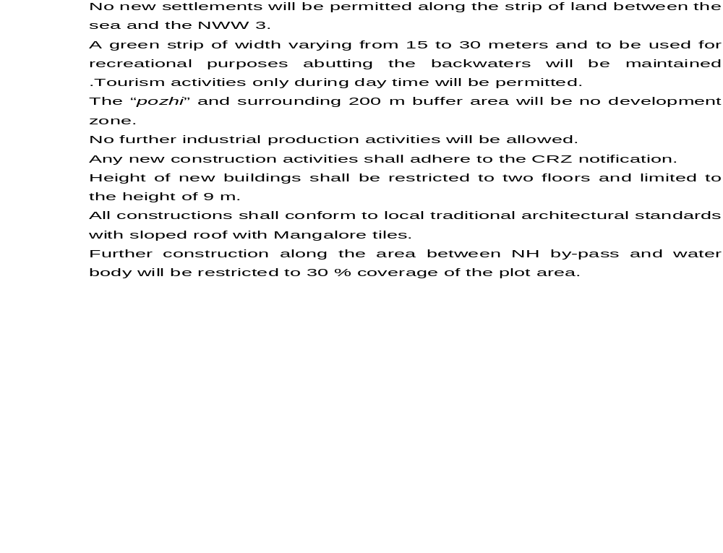

(b). Detailed Guidelines are given below:

- Residential cum tourism development zone. The area is covered under the following survey No.s:

222(p), 223(p), 226, 225(p), 227(p), 228(p), 229, 230, 238, 239, 240(p), 241(p), 242(p), 243(p), 244(p), 245(p), 246(p), 402, 403, 404, 406, 407(p), 408(p), 409(p), 410(p), 411, 412, 417(p), 418, 419, 420, 421(p), 422(p), 423(p), 496, 497, 498, 499, 500, 501, 502(p), 503, 504, 505, 506, 511, 512, 513, 514, 515, 516(p), 517(p), 518, 519, 520, 521, 522, 523(p), 524(p), 525, 526, 527, 528, 529, 530, 531(p), 532, 533(p), 534, 539, 540(p), 541(p), 542, 543, 544, 555, 557, 578(p), 560(p), 561(p), 562, 563(p), 564(p), 565, 566(p), 567(p), 568(p), 569, 571, 572, 573, 574(p), 575, 576(p), 579, 580, 581, 595(p).

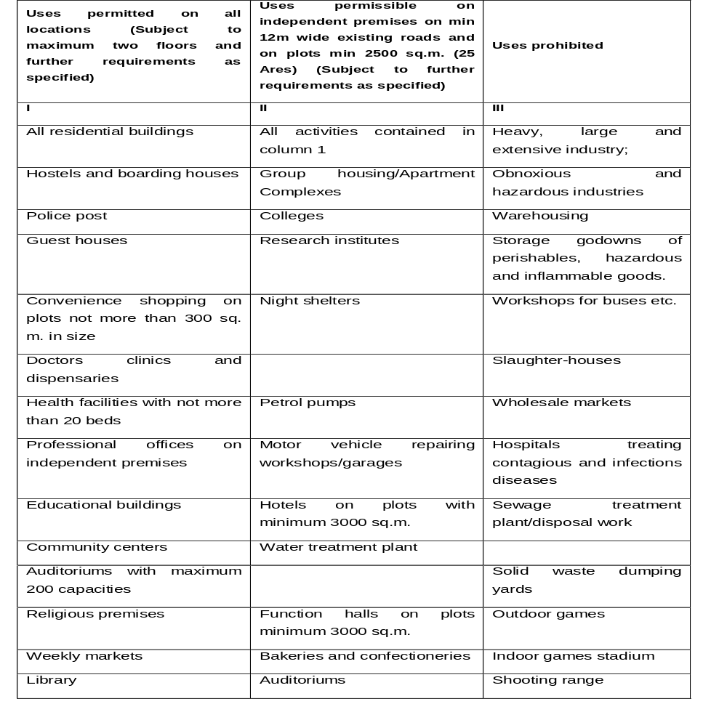
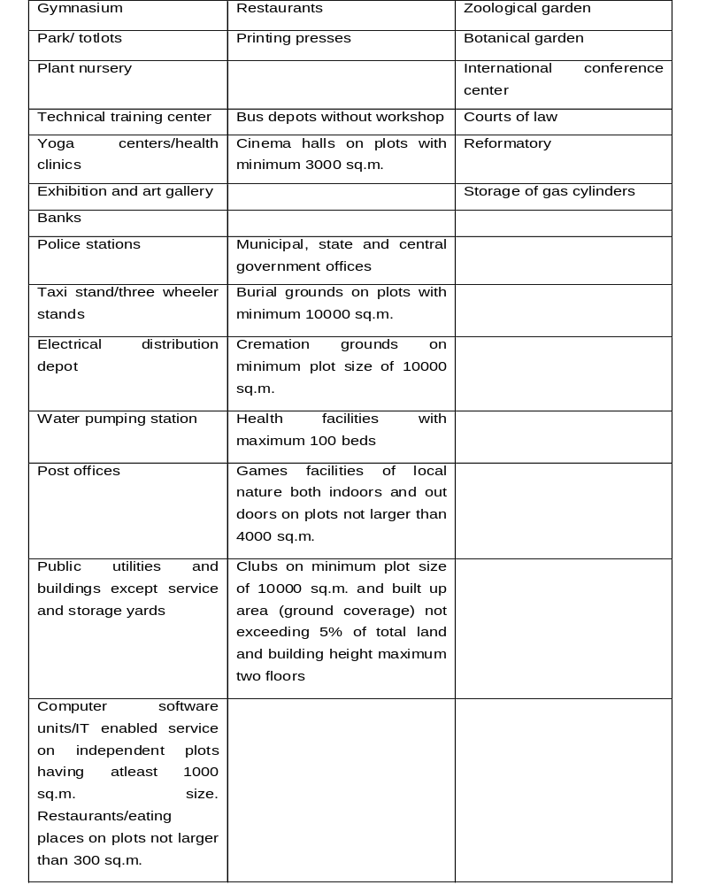

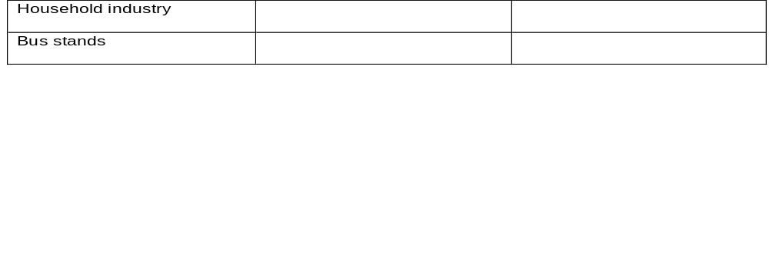

(ii) All tourism related infrastructure to be constructed in this area

shall have its own individual plot with a minimum size of 25 cents with compound wall, motor-able access of width more than 5m and shall have its own arrangements for water supply, sanitation, solid and liquid waste disposal mechanism.

(b). No Development zone. The zone is covered in areas with
survey No.s :

429, 432, 433, 434 , 435, 436, 437,438, 439(p), 440, 441, 442,
443, 444, 445, 446, 447, 448, 449, 451.

The following guidelines shall be adhered to

- No developmental activity shall be carried out for a distance of 10 m from the backwaters except gardens, pastures, landscaping, boat landing etc.
- No further new construction will be permitted other than those
specified in this section.
- Sand extraction in and around water bodies is strictly
prohibited.
iv. All design shall conform to local architectural patterns and
ambience with Mangalore tiled roofs.
v. Boat landing facilities shall be constructed, spatially
distributed around the island at about 3 to 4 points for tourist
facilitation.
vi. Pathways shall be designed and built aesthetically with natural
coloured pavements and lighting arrangements.
vii. Play grounds for various sports meeting international standards
viii. Children’s traffic parks & camping grounds
ix. Picnic huts with built up area not exceeding 2% of total area
and building and structures ancillary to use permitted.

x. Comfort stations with own arrangements for treatment plants of

not more than 25m2.
xi. Convenient shopping stalls of size not more than 15m2. Convenient shopping stalls of size not more than 15m2.
xii. Small huts of size up to 30m2 meant for herbal / Ayurvedic
massage / treatment centers propagating indigenous medicines

c. Mixed Zone (Settlement and Tourism Zone)

(i.) This zone falls with in the boundaries covered by survey No.s :

28(p), 29, 39, 41, 42, 43, 46, 47(p), 48, 49(p), 50, 197 to 200, 203, 205 to 207, 209 to 220, 232 to 236, 249 to 254, 255 to 281, 283, 284, 286, 293 to 295, 305, 306, 308, 311, 312, 314 to 316, 319 to 322, 328, 331, 337 to 341, 344, 347, 349, 350, 352, 353, 354, 356, 357, 358, 361, 362, 364 to 367, 368 to 400, 414, 415, 451, 494, 546 to 554, 583, 584, 587, 588 to 593, 596, 597, 599 to 601, 604, 605, 606, 608 to 610, 613, 614, 616, 617, 635 to 638, 640 to 643, 649, 650, 652 to 661.

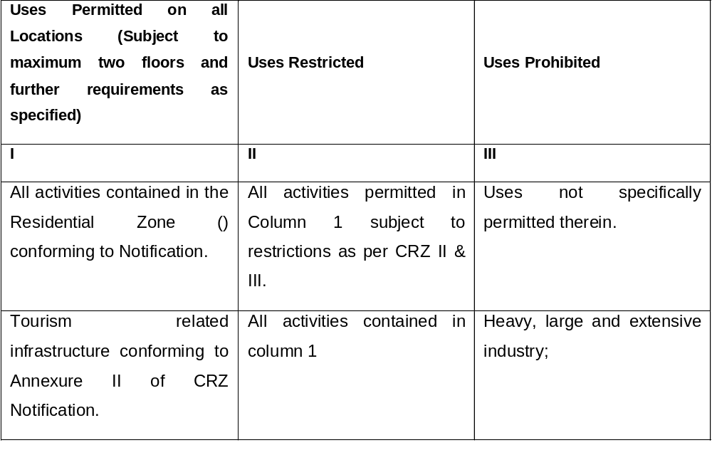

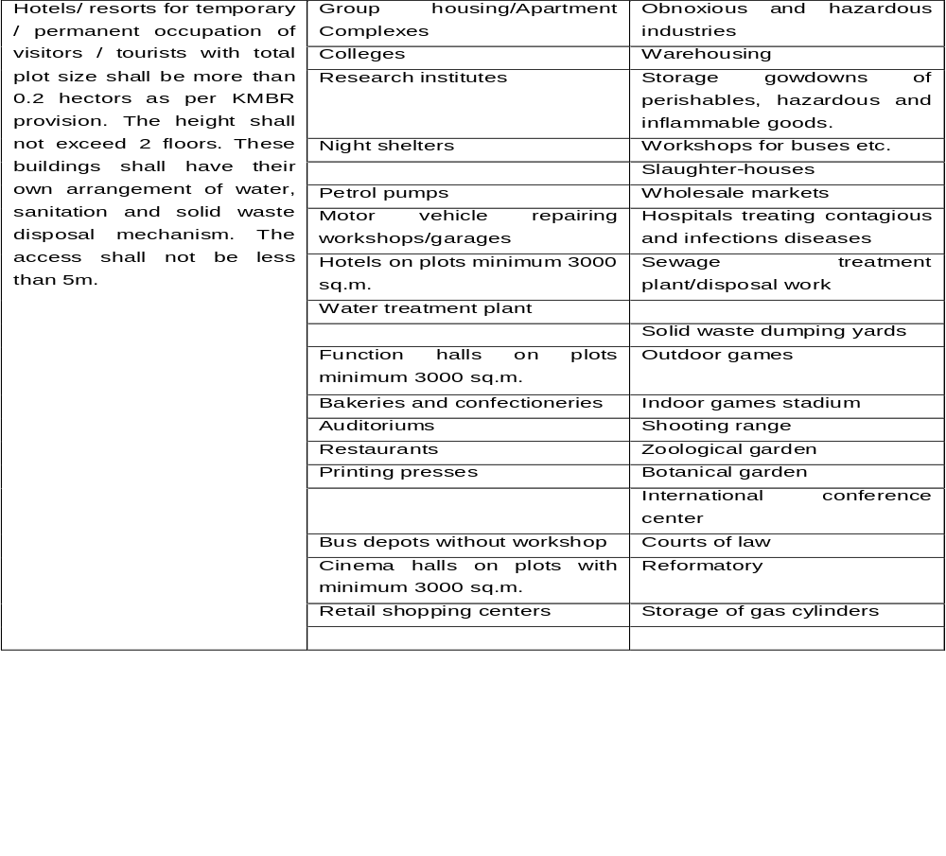

13. Zone 3 (Howah/Eve Beach Area). The area is over crowded with hotels and beach resorts. No further construction will be permitted up to a distance of 500 meters from High Tide Line. Traditional residential settlements beyond 500 m HTL will however be encouraged. A Tourism Facilitating Center should be commissioned within the zone for co-ordinating the development and main thrust should be on land management comprising of updating and computerisation of land records, simplification of land registration, land pooling/plot reconstitution.

14. Demarcations of the zone are given below:

(a) Mixed Zone (Settlement and Tourism Zone.)

(i.) The area is covered in survey No.s:

Vizhinjam village 9(p), 45(p), 47(p),

Thiruvallam 295, 296, 297, 298, 299, 300, 301, 323, 453, 456, 457,
458(p), 459(p), 461, 462, 464, 465, 466, 467, 468, 469,
470, 479(p), 480, 481, 482, 483, 485, 486(p), 487(p),
489(p), 490, 491, 492, 493.

Venganoor 242, 251, 254, 293, 294 to 306, 308(p), 309(p), 310 to
313, 315 to 326, 329.

- For activities permitted refer para 11(c) above

b. No Development Zone. The area is covered under survey No.s:

Thiruvallam Village 452, 458(p), 470 to 478, 479(p), 486(p), 487(p), 488,

489(p).

Venganoor Village 306(p), 307, 308(p), 309(p)

Vizhinjam Village 1 to 19, 21, 23, 26, 27 to 29, 32, 34, 35 to 38, 39(p), 40

to 44, 45(p), 46 to 48, 50 to 55, 57 to 59

The following guidelines shall be adhered to:

i. No further new construction will be permitted other than those
specified here in.

- Pathways for transit movements shall be designed and built aesthetically with natural coloured pavements and lighting arrangements.

iii. Facilities for various sports meeting international standards.

iv. Children’s parks & camping grounds

v. Comfort stations with own arrangements for treatment plants of not
more than 25m2.

vi. Other structure for physical infrastructure like water supply, sanitation,
power etc. with independent units not more than plot area of 20 m2.

c. Settlement Zone.

(i.) The area is covered under survey No.s:

Venganoor Village 227 to 228, 233 to 235, 237 to 239, 244 to

248,257,258, 271, 273, 275 to 277,279,

284, 287(p), 288(p), 289, 342(p), 343, 344,

345, 346, 347, 372, 391, 390.

- All activities covered under paragraph 11(c) above are permitted

15. Zone 4 (Vizhinjam Harbour).

The area comes under CRZ III category regulations. The existing harbour and traditionally built over crowded settlements will be augmented as a modern fishing harbour. Limited scope for domestic tourism exists. Separate enclosures will be provided in the vicinity of the harbour for the convenience of the visitors. The designated landuse zones are:

a) Harbour and Allied Activity Zone. The area is covered in survey No.s:

Vizhinjam Village 33, 61, 62, 63, 64, 65, 66, 67, 71, 72, 73, 74, 75, 76, 77,
78, 79, 81, 84, 85, 86(p), 87, 88, 89(p), 90, 91, 92(p), 93(p), 94, 95, 96, 97, 98, 100, 101(p), 110, 112 to 115 191, 196, 198, 199, 200, 201, 203, 204, 205, 222.

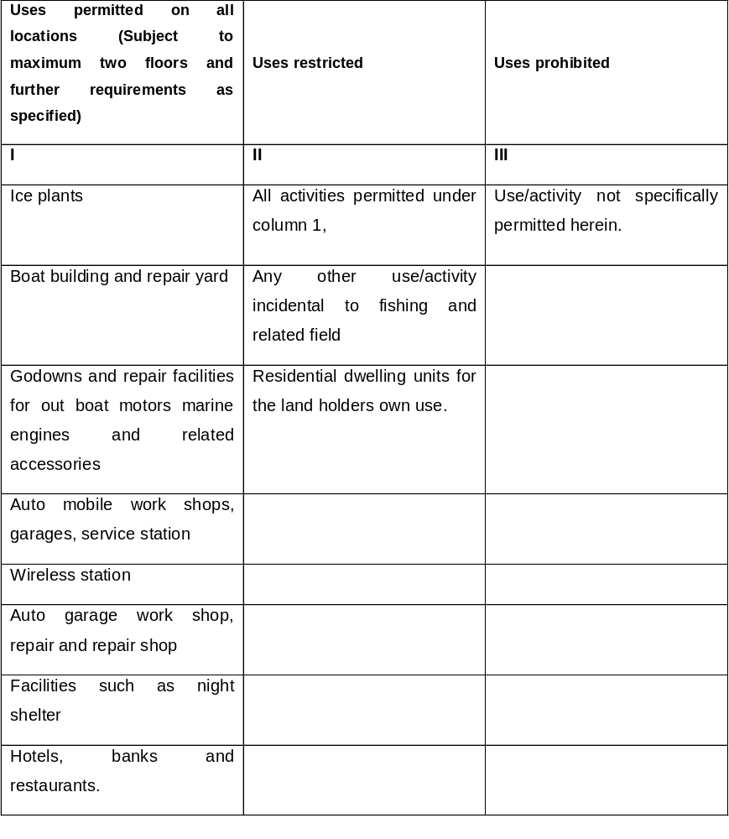

New hotels/Beach Resorts will be permitted in accordance with Annexure II of CRZ notification.

No change will be made to the landform and topography to accommodate buildings and infrastructure.

All hotel/beach resort developed will have a minimum access width of 5 m.

The set back requirements will be met as per the provisions of KMBR.

Parking area will be provided as per KMBR.
No activities will be permitted at CRZ (I) category area.
For hotels, 30% coverage will be allowed for construction with a height restriction of 9m

16. Demarcations of the zone are given below:

a. Tourism Development Zone (with restriction).

- The area is covered in survey No.s:

Vizhinjam Village: 74(p), 75, 81, 88, 89(p), 92(p), 93(p), 96(p), 95, 98(p), 191, 194, 196, 200, 201(p), 202(p), 209(p), 210, 211, 212(p), 213, 214, 217, 240(p), 241(p), 242(p), 247(p), 248, 250 to 256, 257(p), 258(p), 263 to 265, 266(p), 268(p), 272(p), 273 to 276, 277(p), 279(p), 280, 281, 282, 287(p), 288, 289, 699, 701(p), 702,705, 706(p), 707 to 709 712, 715, 716 to 718, 719(p), 720 to 722, 723(p), 726(p), 733(p), 734 to 737, 739, 741, 742(p), 749(p), 750(p), 751(p), 752(p), 754, 755(p), 764(p), 765, 766, 767(p), 768(p), 769, 770(p), 771(p), 773(p), 774(p), 775(p).

Kottukal Village: 342(p), 343(p), 345(p), 346, 347(p), 348 to 350, 351(p), 355(p), 360(p), 365(p) 366(p), 367(p), 370(p), 372(p), 373 to 375, 380, 381(p), 382 to 384, 385(p), 390(p), 391 to 395, 405(p), 406(p), 410(p), 411 to 418, 422(p), 423(p), 424, 425, 426(p), 455(p), 456, 457(p).

ii. Activities permitted are:

Small residences of up to 100m2 built up area with single
floors and plot size not exceeding 500m2.

Comfort stations of built up area up to 25m2.

Independent tourist cottage of size up to 50m2. with tiles roof
Construction

Small huts of size up to 50 m2. meant for herbal /Ayurvedic
massage / treatment center propagating indigenous medicines
Temporary sheds for exhibition or function.

Children’s traffic parks, Camping grounds

Picnic huts with built up area not exceeding 2% of total area
and Building and of 20 m2.

ii. All activities as given in Zoning Regulation of the master plan prepared are permitted.

b) Settlement Zone.

- The area is covered in survey No.s:

Venganoor Village : 284, 329(p), 330, 336, 337, 338,

340(p), 348(p), 349 to 354, 357,

358(p), 360, 361(p), 523(p), 525,

527, 528, 530(p)

Vizhinjam Village : 102, 106 to 109, 111, 117 to 124, 126,
128 to 131, 134, 135, 140, 142 to 145,
148(p), 151 to 166, 167(p), 170, 175 to
193, 220, 342 to 349, 350(p), 351 to 357,
361, 364 to 370, 372(p), 373 to 376,
377(p), 378(p), 381 to 384, 389, 392 to
397, 400 to 402, 406 to 416, 418, 420 to
423, 425, 429(p), 430, 431(p), 432, 433,
434(p), 435, 436 to 474,476 to 482, 484,
486, 488,490, 493, 494, 496, 499, 502 to
505, 507 to 524.

ii. All activities covered under paragraph 11(c) above are permitted

17. Zone 5 (Mulloor Area) and Zone 6 (Pulinkudy).

The area has ample scope for development as a major tourist resort area. Comparatively undistributed areas near Mulloor & Pulinkudy have substantial tourism potential.

New hotels/Beach Resorts will only be permitted in accordance with Annexure II of CRZ notification in CRZ III areas.

No change will be made to the landform and topography to accommodate buildings and infrastructure.
All hotel/beach resort developed will have a minimum access width of 5 m.
No activities will be permitted at CRZ (I) category area.

For hotels, 30% coverage will be allowed for construction with a height restriction of 9m in CRZ III area.

18. Demarcations of the zone are given below:

- Tourism Development Zone (with restriction). The area is covered in survey
No.s:

Vizhinjam Village: 74(p), 75, 81, 88, 89(p), 92(p), 93(p), 96(p), 95, 98(p), 191, 194, 196, 200, 201(p), 202(p), 209(p), 210, 211, 212(p), 213, 214, 217, 240(p), 241(p), 242(p), 247(p), 248, 250 to 256, 257(p), 258(p), 263 to 265, 266(p), 268(p), 272(p), 273 to 276, 277(p), 279(p), 280, 281, 282, 287(p), 288, 289, 699, 701(p), 702,705, 706(p), 707 to 709 712, 715, 716 to 718, 719(p), 720 to 722, 723(p), 726(p), 733(p), 734 to 737, 739, 741, 742(p), 749(p), 750(p), 751(p), 752(p), 754, 755(p), 764(p), 765, 766, 767(p), 768(p), 769, 770(p), 771(p), 773(p), 774(p), 775(p).

Kottukal Village: 342(p), 343(p), 345(p), 346, 347(p), 348 to 350, 351(p), 355(p), 360(p), 365(p) 366(p), 367(p), 370(p), 372(p), 373 to 375, 380, 381(p), 382 to 384, 385(p), 390(p), 391 to 395, 405(p), 406(p), 410(p), 411 to
418, 422(p), 423(p), 424, 425, 426(p), 455(p), 456, 457(p)

- General Regulations:

Small residences of up to 100m2 built up area with single floors and plot size not exceeding 500m2.
Comfort stations of built up area up to 25m2.
Independent tourist cottage of size up to 50m2. with tiled roof construction

Small huts of size up to 50 m2. meant for herbal /Ayurvedic massage / treatment center propagating indigenous medicines
Temporary sheds for exhibition or function.
Children’s traffic parks, Camping grounds

Picnic huts with built up area not exceeding 2% of total area and Building and structures ancillary to use permitted, subject to the total ground coverage not exceeding 2%

- No Development Zone.

i. The area is covered in survey No.s:

Vizhinjam Village : 206(p), 209(p), 257(p), 258(p), 259, 260,
261, 262(p), 266, 267, 268(p), 269 to
271, 272(p), 283 to 286, 287(p), 719(p),
740, 742(p), 743(p), 744 to 748, 749(p)
751(p), 755(p), 756, 757, 759, 760 to
763, 764(p), 767(p), 768(p), 774(p), 775(p), 776(p), 798.

Kottugal Village : 351(p), 352 to 354, 355(p), 356 to 359,
360(p), 361 to 364, 365(p), 376, 377 to
379, 381(p), 419 to 421, 422(p), 423(p),
457(p), 458 to 460,462 to 464, 466 to
470, 472 to 474, 476 to 480, 482 to 484,
486 to 497, 498(p)

- Pathways shall be designed and built aesthetically with natural
coloured pavements and lighting arrangements.

- Regional parks for attracting national & international tourists.

iii. Play grounds for various sports meeting international standards

iv. Comfort stations with own arrangements for treatment plants of not
more than 25m2.

v. Other structure for physical infrastructure like water supply, sanitation, power etc. with independent units not more than plot area of 20 m2.

(d). Settlement Zone. The area is covered in survey No.s:

Kottukal Village: 267 to 276, 312 to 327, 338 to 498, 340, 341(p),

342(p), 343(p), 344, 345(p), 366(p), 367(p), 369,

370(p), 371, 372(p), 385(p), 386, 389, 390(p),

395(p), 396(p), 397, 398 to 404, 405(p), 406(p),

407, 408, 409, 410(p), 424(p), 425(p), 426(p),

427 to 434, 437 to 453, 455(p).

(i). All activities covered under paragraph 11(c) above are permitted

CHAPTER 4

Building Regulations

19. Building Regulations

Kerala Municipality Building Rules 1999 is applicable for all the scheme areas and the following additional provisions have to be enforced.

a. For areas of heritage precincts of historical, scenic and ecological importance, a special set of building regulations decided by the Art and Heritage Commission, Kerala, shall apply in addition to the provision for water conservation mentioned here under.

b. The ground surface around the buildings on plots larger than 250 sq.m. will have percolation pits of 1.5 m x 1.5 m dimension, covering at least 30% of such area. Such pits will be filled up with pebbles, brick jelly or river sand and covered with perforated concrete slabs.

c. On all plots larger than 250 sq.m, the terrace of the building will be connected to a submerged tank or a well, through a filtering tank, by an appropriate rain water pipe.

d. A filtering tank measuring at least one cubic meter will be constructed near the submerged tank. A perforated slab will divide the tank into two chambers and one chamber will be filled with pebbles and other with brick jelly. The bottom portion of the tank will have a slope to avoid stagnation of water.

20. Guidelines for construction in CRZ are enclosed as Annexure B & C.

CHAPTER 5

Special Regulations

20. Access

The major access to the tourism destination is through NH bypass. The widening proposals envisaged in the Master Plan are considered in the new plan in totality. The provision of the roads will be as per Indian Road Congress (IRC) specifications.

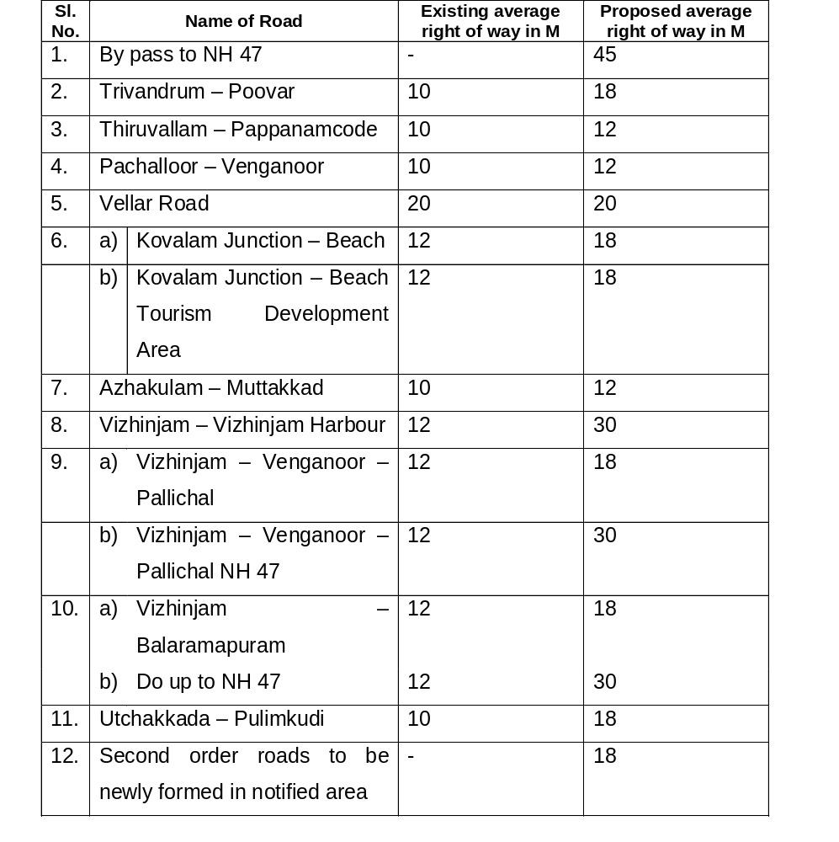

21. Protection of Scenic Environment
The landform topography and flora reinforce the virgin natural beauty of the Special Tourism Zone shall be conserved.

22. Guidelines

(a). Building structures shall not obstruct the panoromic view of the sea/horizon from a common beach area.

a. Proponents will prepare a visual resource management plan, addressing the existing landform, vegetation and prominent features (to and from the proposed site).

b. Only locally endemic vegetation is propagated for screening, windbreaks, rehabilitation and landscaping

c. Weeds are monitored and eradicated wherever appropriate;

d. No change is made to landform (cut and fill) and topography to accommodate buildings and infrastructure;

e. Disturbance or loss of natural vegetation not permitted except for the areas of actual constructions;

f. Local sources of gravel, stone and earth are used, subject to approval;

g. Architectural style, landscape design and construction materials shall reflect local elements (eg. landform);

h. Materials with muted or recessive colours and low reflective qualities that closely compliment the neighborhood are used;

i. Services including electricity lines are located below ground (for all new tourism related developmental activities);

j. Isolated structures, such as car parks, toilet blocks, towers and storage areas blend into the natural setting and with locally endemic vegetation; and

k. Quarrying and sand mining will be banned.

23. Guidelines for Foreshore Set Back

(a) Landforms and natural systems and the costal zone differ from zone to zone in Kovalam and surroundings. Due to this diversity, setbacks for development with in the coastal zone will be strictly as per CRZ guidelines.
(b) For all constructional or developmental activities, even if in accordance with the CRZ norms, sufficient setback will be provided so as not to obstruct the scenic view of prominent landmarks and major attractions, such as headlands, cliffs and beaches.

(c) The common land in the foreshore setback area through out the entire scheme area will be free from individual fencing/compound wall.

(d) Signage, bollards, display boards, rubbish bins and small structures (water tanks or toilet blocks) within the foreshore area have a very low visual impact and are of a form (colour, material and size) consistent with the amenity and character of the area.

(e) Foreshore access roads and car parks will follow natural contours.

(f) Pedestrian access will be created as principal access through out the entire scheme area.

(g) Stabilisation, rehabilitation, re-vegetation and landscaping of the foreshore setback are undertaken using locally endemic plant species.

24. Guidelines for Marine Infrastructure

Marine structures and boat landing facilities existing and proposed will strictly follow approved management guidelines of Harbour Engineering Department. Shore support facilities with eco-friendly practices will be considered only in the designated locations of fishing harbour.

25. Guidelines for Water Availability

(a) Development proponents will endeavor to obtain water from a variety of sustainable sources, with collection of rainwater being a priority; detailed schemes will be submitted along with preliminary application.

(b) Water conservation strategies like composting toilets and storm water re-use will be incorporated in development proposals.

(c) All new proposals will have the mechanism of rainwater harvesting measures.

(d) Water quality standards are:

(i). Indian Standards of Drinking Water .The Bureau of Indian Standards has defined the level of solvents for safety purposes. The table below gives the common solvents in water and the permitted levels.

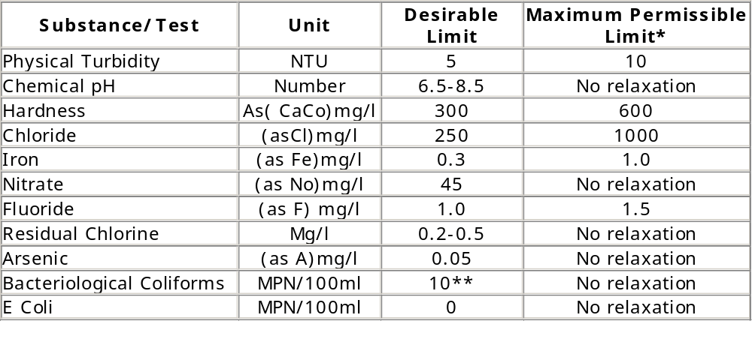

* When there is no alternative source for drinking.
** Colitone organisms should not be detectable in 100ml of any two consecutive samples.

(ii) Water Quality Standards.

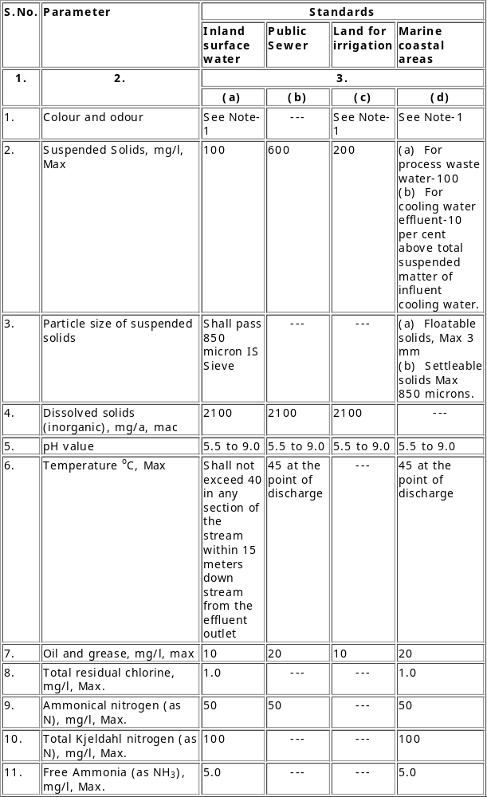

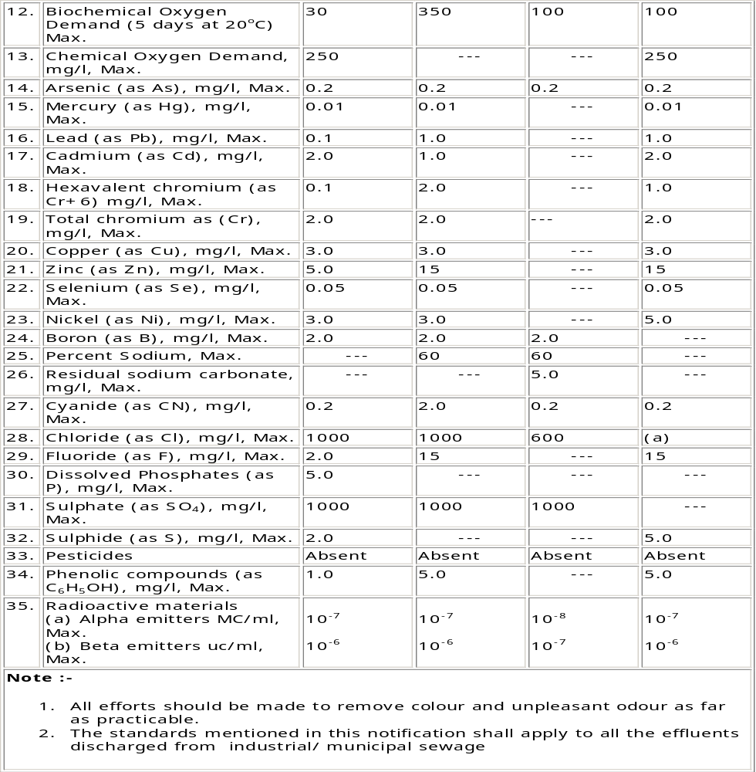

26. Guidelines Sewage Treatment

- Provisions contained in Water Act, 1974 and effluent standards for the sewage laid down by Kerala State Pollution Control Board.
- Water recycling techniques will be adopted to minimize water use and maximize recycling for all new proposals.
- Treated sewage will be disposed off by trickle/drip irrigation to natural vegetation (not within 100 M of beaches or wetlands) instead of disposal to the marine environment.
- Screened solids and sludge should be transported to a licensed landfill or to Vilappilsala solid waste Treatment Plant.
- Ensure that the discharge water meets the criteria specified at paragraph 25 above.

27. Guidelines for Waste Disposal

Organic and green waste will be collected, treated by windrow composting and stored for use as mulch, soil improver or fertiliser.

Organic waste not used composting and all inorganic waste will be transported to a licensed landfill facility or waste treatment plant of the Thiruvananthapuram Corporation.

Development proposals for waste management programme will cater to minimizing waste production and reuse and recycling. Ensure that the discharge water meets the criteria specified at paragraph 25 above.

28. Guidelines for Energy Generation

a) Diesel generators encased in sound proof structure with mufflers will only be used during emergency situations.
b) Use of heavy energy consuming machineries, which can potentially harm or damage the environment through toxic emissions and other hazardous materials are avoided.
c) Standards/Guidelines for control of Noise Pollution from Stationary Diesel Generator (DG) Sets:

(i) Noise Standards for DG Sets (15-500 KVA)
The total sound power level, Lw, of a DG set should be less than, 94+10 log10 (KVA), dB(A), at the manufacturing stage, where, KVA is the nominal power rating of a DG set. This level should fall by 5 dB(A) every five years, till 2007.

- Mandatory acoustic enclosure/acoustic treatment of room for stationary DG sets (5 KVA and above):

Noise from the DG set should be controlled by providing an acoustic enclosure or by treating the room acoustically. The acoustic enclosure/acoustic treatment of the room should be designed for minimum 25 dB(A) Insertion Loss or for meeting the ambient noise standards, which ever is on the higher side (if the actual ambient noise is on the higher side, it may not be possible to check the performance of the acoustic enclosure/acoustic treatment. Under such circumstances the performance may be checked for noise reduction upto actual ambient noise level, preferably, in the night time). The measurement for Insertion Loss may be done at different points at 0.5m from the acoustic enclosure/room, and then averaged. The DG set should also be provide with proper exhaust muffler with Insertion Loss of minimum 25 dB(A).

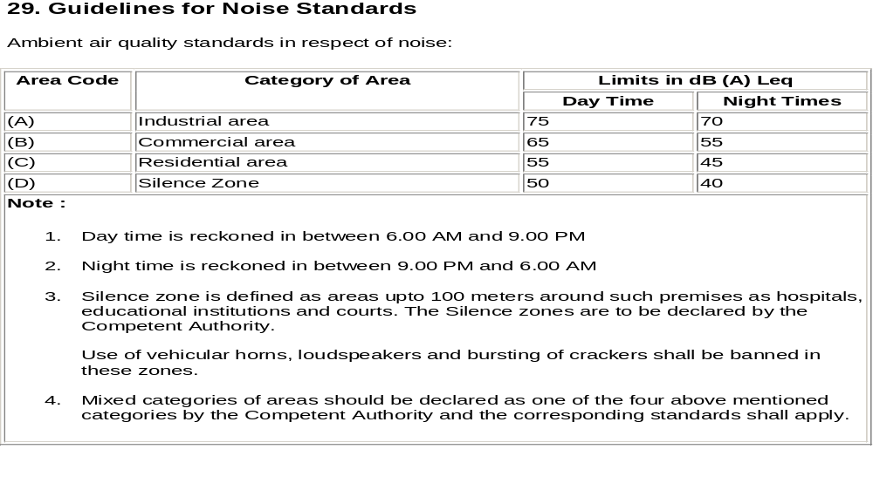

30. Guidelines for Construction and Management

- Construction practices will ensure minimal site disruption.
- Proponents will develop on-site guidelines and controls for contractors, specifying appropriate construction practices.
- Minimal use and disposal of dangerous chemical cleaning products will be encouraged. Where disposal is unavoidable, low environmental impact products will be sought.
- Proponents will prepare and adopt a product purchasing policy, which maximizes use, reuse and recycling.

31. Guidelines for Mandatory Planting of Trees

(a) The number of trees to be planted and their subsequent maintenance will be on the following scale.

- Residential areas: Every household having more than 100 sq.m. area will plant at least small or medium variety in their premises as follows:

Table 1

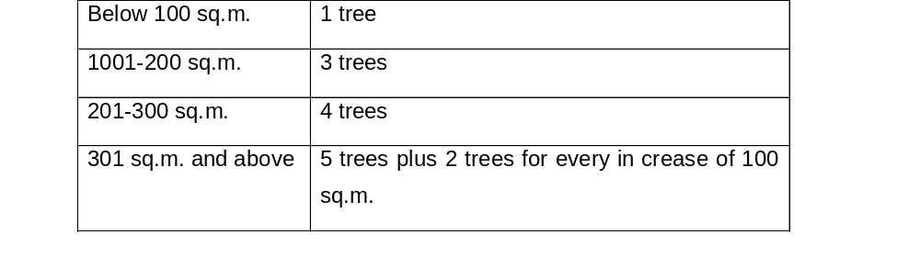

- Commercial or institutional cases: Commercial establishment will plant trees as follows:

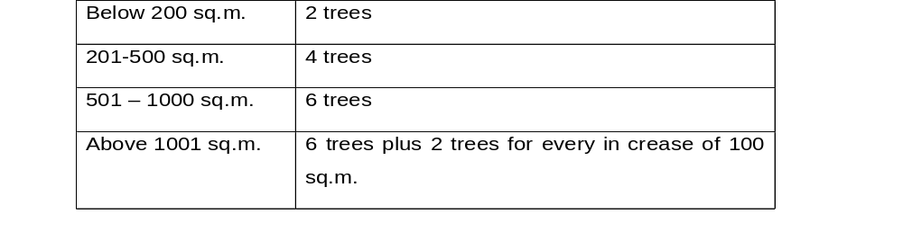

In addition, commercial or institutional areas will be landscaped instead of leaving them without any vegetation.

(c) The local authority having jurisdiction will grant building permission
subject to the condition that the owner shall plant the prescribed
number of trees.

(d) The owner of the premises or house will maintain the trees and will not fell them without the permission of the designated officer.

32. Guidelines for Waterways, Canals and Streams. No outlets from any hotel will be discharged directly to these drains without having treated the effluent. The natural streams will not be filled up.

CHAPTER 6

SPECIAL REGULATION TO RESTAURANTS, AYURVEDA CENTRES, HOUSEBOATS

RESTAURANTS

Introduction

33. The cuisine of Kerala is one of the most sought –after tourism products of God’s Own Country. The number of tourists, who find our divine dishes irresistible, is fast increasing. So is the number of restaurants, which cater to tourists from all over the world. Hence it has become urgent to evaluate the quality and service standards of restaurants and classify the accordingly. This will ensure the customers high quality, hygienic services of international standards. As part of its ongoing efforts towards sustainable tourism products and ensuring high standards in services, Kerala Tourism is now introducing regulatory measures for the working of restaurants these guidelines are issued to regulate how restaurants will be classified, the terms and conditions and the application format are placed at Appendix E attached.

General terms and conditions

34. Classification from the Department of Tourism, Government of Kerala is not mandatory to operate a restaurant in the State. Classification for newly operational restaurants must be sought with in 3 months of completion of restaurant projects.
Operating restaurants may opt for classification at any stage. However, restaurants seeking re-classification should apply one year prior to the expiry of the current period of classification. If the restaurant fails to reapply one year before the expiry of the classification order, the application will be treated as a fresh classification case.
Once a restaurant applies for classification/re-classification, it should be ready at all times for inspection by the Restaurant Classification Committee of Kerala (RCCK). No requests for deferment of inspection will be entrained. Classification will be valid for 3 (three) years from the date if issue of orders or in case of re-classification, from the date of expiry of the last classification provided that the application has been received with in the stipulated time mentioned above, along with all valid documents. Incomplete application will not be accepted. Restaurants applying for classification must provide the following documentation.

a) All applications for classification or re-classification must be complete in all respects
b) Application form
c) Application fee
d) Prescribed clearances
e) NOCs, certificates etc.
(Incomplete application is liable to be rejected.)

35. The application fees payable for classification are as follows:

Star category Classification/re- classification fee in Rs.
1-Star2-Star 3-Star 6,000
4-Star5-Star 10,000

36. The Restaurant Classification Committee of Kerala (RCCK) consist of the following:

Secretary (Tourism) - Chairman
Director, Department of Tourism - Convener
Principal, IHMCT - Member
Representative from FHRAI - Member
Representative from HAI - Member
Representative from IATO - Member
Representative from TAAI - Member
Four members will constitute a quorum
The chairman, RCCK, will approve the minutes.

37. The presence of facilities and services will be evaluated against the enclosed
checklist. Refer para 51 below.

38. New projects will be required to adopt environment friendly practices.

39. Existing restaurants being classified will need to conform to a phased plan for
adding eco-friendly practices and facilities

40. The quality of facilities and services will be evaluated against the mark sheet.

41. The restaurant is expected to maintain required standards at all times. The Classification Committee may inspect a restaurant at any time with out previous notice.

42. Any deficiencies /rectification pointed out by the RCCK must be compiled with within the stipulated time, which has been allotted in consultation with the restaurant representatives during inspection. Failure to do so will result in rejection of the application.

43. The committee may assign a star category lower but not higher than that
applied for.

44. The restaurant must be able to convince the committee that they are taking Sufficient teps for energy conservation, water harvesting, garbage segregation, and disposal/recycling as per Pollution Control Board (PCB) norms and following other eco- friendly measures.

45. For any change in the star category the promoters must apply afresh with an
application form and requisite fees for the category applied for.

46. Any change in the plans or management of the restaurant should be informed
to the RCCK, Department of Tourism, and Govt. Of Kerala within 30 days. Otherwise the classification will stand withdrawn / terminated.

47. Applicants are requested to go through the checklist of facilities and services
contained in this document before applying. Incomplete applications will not
be considered.

48. All cases of classification would be finalized within three months of the
application being made.

49. The Department of Tourism, Govt. of Kerala reserves the right to modify the guidelines/terms and conditions from time to time.

50. Awarding Scores

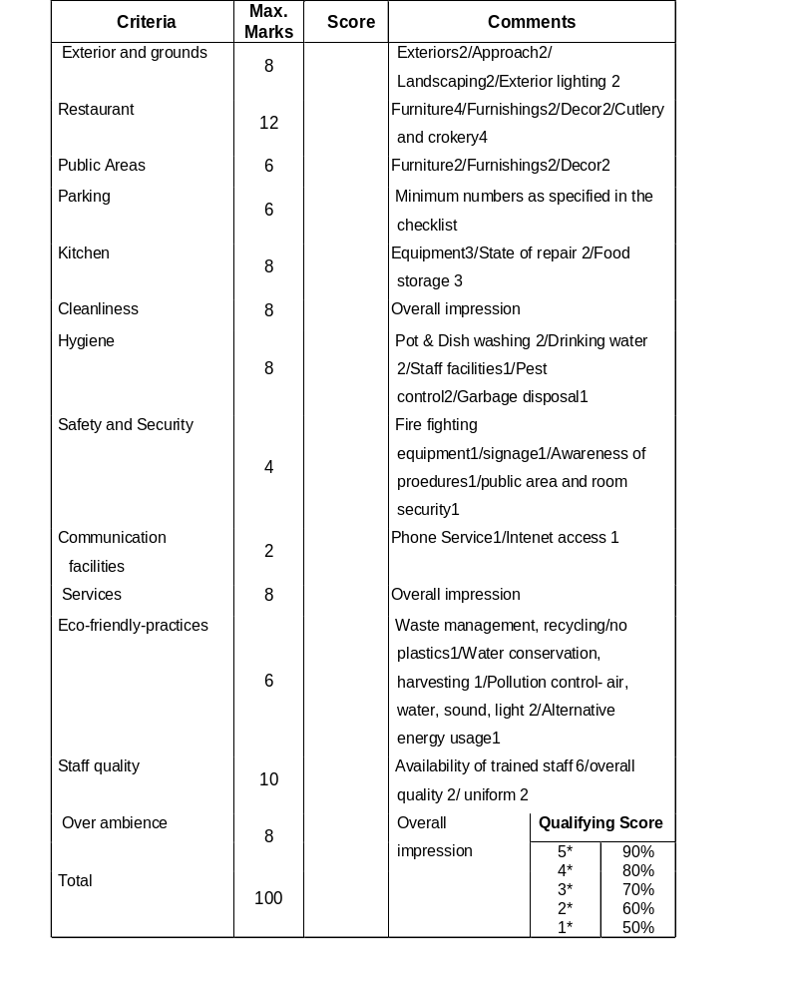

51
CHECK LIST FOR FACILITIES & SERVICES

General 1* 2* 3* 4* 5*
Minimum 2-mesl operation, 7 days a weak in season N N N N N
Establishment to have all trading license N N N N N
24hrs lifts for building higher than ground plus two floors N N N N N
Restaurants, public areas and kitchens fully serviced daily N N N N N
All floor surfaces clean and in good repair N N N N N
Parking facilities (Maximum no. of seats per unit car parking area 12 10 8 6 4

Restaurant
Multicuisine restaurant of min.30 pax and 600 sq.ft carpet area N N N N N
Speciality restaurant D D D N N
24hrs coffee shop D D D N N
Full service of all 3 meals in dining room N N N N N
Crockery and glassware of high quality N N N N N
Cutlery to be at least stainless steel N N N N N

Kitchen
Refrigerator with deep freeze N N N N N
Segregated storage of meat, fish and vegetable N N N N N
Tiled walls, non-slip floors N N N N N
Head covering or production staff D D N N N
Daily germicidal cleaning of floors N N N N N
Clean Utensils N N N N N
Six monthly medical checks for production staff N N N N N
All food grade equipment, containers N N N N N
Ventilation system N N N N N
First-aid training for all kitchen staff N N N N N
Drinking water N N N N N
Garbage to be segregated – wet and dry N N N N N
Receiving and stores to be clean and district from garbage area N N N N N
Insectocutor N N N N N

Public Areas
A lounge or seating in the lobby area D D D N N
Reception facility D D D N N
Souvenir shop NA NA D D D
Public Telephone NA NA NA D N
Internet facility and tourist information kiosk NA NA NA D D
News papers available N N N N N
Conference facilities NA NA NA D N

Staff Quality

Staff uniforms D D N N N
Hand gloves and cap for kitchen staff N N N N N
English speaking front office staff D D N N N
Government recognized catering/hotel institutes 10% 15% 20% 40%50%
Staff welfare/facilities D D N N N
Staff rest rooms D D N N N
Staff locker rooms D D N N N
Dining Area D D N N N

Common Toilets

Separate gents and ladies toilet N N N N N
Access to the toilets not through kitchen/restaurant N N N N N
Minimum number of gents W.C 1 1 2 2 2
Minimum number of ladies W.C 1 1 2 2 2
Minimum number of gents urinal 1 1 2 2 2
Cleaning of the area in every 2hrs 2hrs 2hrs 1hr 1hr
A wash basin with running water, a mirror, a sanitary bin with-
lid separate for gents and ladies with hand towels 4 4 4 4 4
Minimum size of W.C. in Sq.ft. 12 12 15 15 15
One W.C. brush per toilet seat N N N N N
Guest toiletries including liquid soap to be provided D D N N N
Floors and walls to have non-porous surfaces N N N N N
Energy saving lighting N N N N N
A notice showing staff should wash their hands every time they
visit bathroom (in Malayalam & English) N N N N N

Safety and Security

Staff trained in fire fighting drill N N N N N
Security arrangement for all entrance N N N N N
Smoke detectors D D N N N
Fire and emergency procedure notices displayed D D N N N
Staff trained in first aid D D N N N
First aid kit with over the counter medicines with front desk D D N N N

Eco-friendly practices

Waste Management N N N N N
Water harvesting and conservation N N N N N
Water recycling D D N N N
Energy saving lights N N N N N
Alternate energy use D D D D D
Pollution control measures D D N N N

Note: D = Desirable, N = Necessary, NA = Not Applicable. There is no relaxation in the necessary criteria.

AYURVEDA CENTRES

Introduction

- The Ayurvedic system of medicine has become very popular among tourists in recent times. Especially in Kerala, where Ayurveda is ‘a way of life’. Kerala is the only place where Ayurveda is practiced in its true and authentic form. Tourists from all over the country and abroad are seeking healing in Kerala’s numerous Ayurvedic centers. Because of his popularity, the number of centers opening up across the State and is also substantially increasing. So much so that there is an urgent needs to evaluate the safety and service standards of Ayurveda centers and classify them accordingly. This will be the first step towards sustaining this unique tourism product. For the purposes of classification of Ayurveda centers, these guidelines are designed.

Essential conditions for classification of Ayurveda centres

52. Essential conditions are given below:

Personnel. Treatment/therapy should be done only under the supervision of a qualified physician with a recognized degree in Ayurveda, who will be present with in the complex while treatment is going on.

There should be at least two masseures (one male and one female) having sufficient training from recognized Ayurveda institutions.The masseures will have minimam one year of practical experience under a qualified Ayurveda physician after completing a minimum period of one year training on Anatomy and Marmas or pressure points( should be understood as junction or meeting places of the 5 organic principles : ligaments, vessels, muscles, bones and joints, with the four types of vessels being the nerves, lymph, arteries and veins).

Male masseures will attend to the male patients and female masseures attend the female patients.These masseures will not attend to patients in the absence of the qualified Ayurveda physician of the Ayurveda centres

Quality of medicine and health programmes. The center will offer only those programmes, which are approved by the Tourism Conservation and Preservation Committee.

Health programmes offered at the centre should be clearly exhibited. The time taken for massages and treatment should be stated. The general approved time limit for a massage is 45 minutes

The medicine used should be from an approved and reputed firm. The medicines should be labeled an exhibited at the Ayurveda centre.

Equipment. One massage table of minimum size 7ft x 3ft in each treatment room, made up of good quality wood as prescribed by the Ayurveda science.

Gas or electric stove

Medicated hot water facility for bathing and other purposes

Facilities for sterilization

Equipment and apparatus should be clean and hygienic

Facilities. A minimum number of two treatment rooms (One for males and One for females) having a minimum size of 100 sq. ft. (width not less than 8ft). The rooms should have good ventilation. There should be an attached bathroom, of size not less than 20 sq.ft. The toilets should have proper sanitary fittings and floors and walls should be furnished with tiles.

One consultation room with a minimum size of 100sq.ft (width not less than 8ft.). The room should be well equipped with medical instruments, like BP apparatus, stethoscope, an examination couch, weighing machine etc.

There should be a separate rest room (minimum size 100sq.ft, width not less than 8ft), if the centre is not attached to a hotel/resort/hospital

General infrastructure of the Ayurveda centre should be good. Locality and ambience, including accessibility, should be suitable. Furnishing should be of good quality. The centre and surrounding premises should be kept clean and hygienic

Optional conditions for classification

53. Optional conditions for classification are:

a. Ayurveda centers will be awarded the Green Leaf on the fulfillment of certain optional conditions. These are the general construction, architectural features etc. of the building should be of very high standards, the furnishings, curtains, fittings etc. should be of superior quality materials. There should be adequate parking space in the premises. The bathroom should have facilities for steam bath

b. Additional desirable conditions for centre seeking the Green Leaf are that there should be a separate hall for meditation/yoga. The centers should be located in picturesque locations with green surroundings and a quiet ambience. There should be a herbal garden attached to the centre

Procedure of classification

54. Every person operating an Ayurveda centre in the state, desirous of getting classification from the Department of Tourism, Government of Kerala should apply for classification in the prescribed application form. The application form is available at the Directorate of Tourism, free of cost, sample given at Appendix F attached. All the applications duly filled should be addressed to the Director, Department of Tourism, Park View, Thiruvananthapuram – 33.

A fee of Rs. 2500/- should be enclosed with the application form by way of Demand Draft drawn in favour of the Director, Department of Tourism, Park View payable at Thiruvananthapuram.

The Director, Kerala Tourism will, unless refused, issue a classification certificate to the Ayurveda centre on the recommendation of a committee consisting of the following members, after inspection.

Director, Kerala Tourism - Convenor
Director, Indian Systems of Medicine - Member
Professor Kayachikitsa, Government Ayurveda College
Thiruvananthapuram - Member
Representative of Ayurveda College Kttakkal - Member
Representative of Indian Association of Tour Operators - Member

The committee will specify the health programmes to be offered in each centre, after considering their facilities.

55. The period of classification will be three years. After the expiry of the classification period the centre has to apply for classification again. Ayurveda centers already approved by the Department of Tourism under the existing scheme will also have to apply for classification, if they so desire. If not, these approved units will be considered only as ‘Approved Ayurveda Centres’, till the expiry of the period of approval.

56. The Department has prescribed regulatory conditions to be abided by promoters of classified Ayurveda centers. The promoters should furnish the acceptance of these regulatory conditions in the prescribed form and execute an agreement on stamped paper (Rs.50/-) with this.

Government subsidies for classified Ayurveda Centres

- Ayurveda centers, which have been classified/approved by the Government of Kerala, will be eligible for claiming a 10% state investment subsidy or electric tariff concession offered by the Department of Tourism, as per G.O. (MS) 140/98/GAD dated23.03.1998.

HOUSEBOATS

58. The houseboats holidays of Kerala are increasingly becoming popular with domestic as well as international tourists. Consequently, the number of houseboats plying the backwaters of Kerala has increased dramatically. So much so that there is an urgent need to evaluate the safety and service standards of houseboats and classify them accordingly. This will be the first step towards sustaining this unique tourism product.

59. These guidelines are designed to provide criteria for classifying the houseboats in Kerala, an initiative that will once again make Kerala pioneer in the tourism industry in India so far as emphasis on quality goes.

- A houseboat fulfilling all essential conditions prescribed by the Department of Tourism and another five of the ten optional conditions will be awarded the status of Gold star. Those fulfilling the essential conditions will be awarded the Silver Star.

Essential conditions for approval Houseboats:

61. The general construction of the houseboat should be good; the hull and valavara should be of good condition; flooring should be of marine plywood.

62. Size of rooms in the house boat should not be lesser than the specifications mentioned below:

Bed rooms : 80 Sq.ft.(minimum width-7 ft.)
Living/Dining : 80 Sq.ft
Kitchen : 20 Sq.ft.
Attached Toilet : 20 Sq.ft. (minimum width-3 ft.)
Common toilet : 10 Sq.ft.
Passages : 3 ft.wide

Bedrooms should be provided with an attached toilet. Toilets for guests should of western style and should be cleanly maintained. A common toilet for the staff of the houseboat should also be provided.

The Kitchen must have provisions for protection from hazards by
Using fire proof materials
Having at least two fire extinguishers

Storage hold in the kitchen must be hygienic food materials on board should be packed properly and store in as clean environment

Fuel storage should not be near the kitchen
The houseboat should have at least two life buoys and 2 fire buckets
Furniture provided in the houseboat should be of good quality.
Clean and good quality linen and toiletries should be used. Crockery and glassware should be of excellent quality.
Houseboats must maintain and regularly update logbooks and tourist records.
Staff members interacting with guests should be in uniform.

The boat should have obtained a valid license from the appropriate authority for playing in the backwaters.

Name, cut number and approval number should be painted on both sides of the houseboat.

Optional condition for approval

- The general construction of the houseboat should show distinctive qualities of luxury. The houseboat should be furnished with superior quality carpets, curtains, furniture etc.

Alternative arrangements for discharging solid wastes and sewage, like scientifically designed septic tanks and chemical toilets.

Houseboat should be battery operated.
Provisions of 24-hour electricity on board the houseboat for lights and fans.
Provision of 24 hour hot and cold running water.
Availability of facility for purifying water on board the house boat.
Provision of a refrigerator or icebox on board.
Arrangement for providing guests a menu of their choice.
Staff members interacting with guests should be experienced and fluent in English.
Houseboats approved by the Department of Tourism should fly a flag inscribed with the mnemonic of the accorded status. The flag will be approved by the Department of Tourism.
The Green Palm certification of House Boats

The houseboat satisfying the essential conditions and adhering to eco-friendly measures prescribed by the Department of Tourism will be awarded the Green Palm Certificate. The condition under which houseboats will be accorded this status are given below:

Alternate arrangements should be made to:

o Collect all solid wastes generated with in the boat for discharge on shore at specified locations.
o Treat sewage by providing scientifically designed septic tanks.
o Collect and store all waste water after washing and cleaning of utensil using detergents.
o Collect all cleaning materials like cotton wastes/rags for disposal on shore at specified locations.
o Bio-chemical toilets may also be used.

Alternate sources of energy for fuel, like solar power, to be used for heating, lighting etc.
Arrangements of a system of separating recyclable from non-recyclable garbage. Organising the disposal of non-biodegradable garbage in such a manner so as not to harm the local environment.

Use of paper bags, cloth bags and other alternatives instead of polythene bags, wherever possible.
Use of recycled paper for stationary and other publicity materials.
Use of locally available ethnic materials for construction of houseboats and furniture.

At least 75% of the workers in a houseboat should be employed from districts of the houseboat’s operation.

Houseboats using out board engines should acquire a pollution control certificate every three months from a competent authority.

Procedure of approval

64. Every person indenting to start operations ion the backwaters of Kerala should, if desiring to get classification, apply for approval to the Department of Tourism in the prescribed form. Those already operating houseboats should apply for the approval if they desire to get classification from the Department of Tourism. The application form is available at the Directorate of Tourism free of cost, sample enclosed at Appendix–G attached. The applications duly filled should be addressed to the Director, Department of Tourism, Park View, Thiruvananthapuram.

A fee of Rs.500/- per houseboat should be enclosed with the application form by way of Demand Draft drawn in favour of the Director, Department of Tourism, Payable at
Thiruvananthapuram.

Unless the application is rejected, the Director of Tourism will issue a certificate of approval to the houseboat operator, on the recommendation of a committee. The committee will give the recommendation after inspection of the houseboat. Members of the committee are:
Director of Tourism (Convenor)
Representative of Travel Agents Association of India (TAAI)
Representative of Approved & Classified Hotel Association of Kerala (ACHA)
Two members nominated by the State Government

- The approval will be valid for one year. The committee will inspect the houseboats every year between the months of September and October. The houseboats should be brought or inspection at the place where the committee desires, at the expenses of the owners. The promoters should furnish a declaration accepting the regulatory conditions to be abided by the promoters of approved houseboats in the prescribed form.

Govt. Subsidies and License

- Only the houseboats approved by the Department of Tourism under this scheme will be eligible for claiming 10% state investment subsidy, eligible as per G.O.(P) No.14/88/GAD dated 12.11.88. The classification obtained under this scheme is not substitute for the license/sanctions required will be obtained from the authorities concerned under the existing rules and regulations.

Statutory conditions for approval

67. All houseboats approved by the Department of Tourism are required to furnish the following information;
Document relating to legal status, i.e. if the company is incorporated in the Companies Act.

Copy of the memorandum and Articles of Association

Copy of the partnership deed and the certificated of Registration under the
partnership Act, if it is a partnership firm
Name and address of the proprietor etc, if it is a proprietary concern.

68. Any license required from the irrigation Department or other concerned authorities to ply the boat in the backwaters should be obtained directly by the promoters. The approval by the Department of Tourism will be withdrawn in case of violation of these conditions, as and when brought to its notice. The houseboat should apply for approval every year before the expiry of the period of validity.

69. The promoter should display the approval certificate, logbook, tariff card on board the houseboat. The logbook should be made available for inspection when required.

In the breech of any of the above conditions, the Department of Tourism has the right to withdraw approval.

CHAPTER - 7

APPROVAL PROCESS

APPROVAL PROCESS

70. Requisite clearance as per CRZ Notification from the Ministry of Environment and Forest will be required for activities falling within the purview. Implications of CRZ notification and guidelines for construction with in the CRZ are given at Appendix A and B respectively.

71. For all other activities the development proposal should proceed in accordance with the planning approval process relevant to the State Town Planning Regulations related to the master plan, to be finally approved by the Tourism Conservation and Preservation Committee.

72. Application for land development / building construction with prescribed fees and enclosures as mentioned in KMBR will be submitted to the local body with a copy to Tourism Conservation and Preservation Committee. The Tourism Conservation and Preservation Committee on receipt of recommendations from the LSGI will approve / reject the proposal indicating reasons for rejection if any.

73. Application format for land development for tourism development activities is
enclosed at Appendix D attached.

APPENDIX

Appendix A
(Refer to Para No: 5)

DEFINITIONS

In these rules unless the context otherwise requires : –

1. “access” means the way to a plot or building ;
2. “accessory use” means any use of the premises sub ordinate to the principal use and customarily incidental to the principal use;
3. “Act” means the Kerala Municipality Act, 1994 (20 of 1994);
4. “advertising sign” means any sign either, free supported or attached to a building or other structure which advertises and individual, a firm, a society, an establishment or a product displayed on the said premises for identification purposes;
5. “alteration” means a structural change, such a s an addition to the area or height or addition of floor/floors or mezzanine floor or changing the roof to concrete slab or re-construction of existing walls or construction of concrete beams and columns amounting to structural change or construction of internal walls for sub-dividing the existing rooms with the intention of changing the use of the room/rooms which amount to change in the occupancy group of the building under these rules, or closing of any required means of ingress and egress to the building;
6. “appendix” means the appendix to these rules;
7. “approved plan” means the set of drawing and statements submitted under these rules for obtaining development permit or building permit and duly approved by the secretary;
8. “bathroom” means a room or cubicle for bathing;
9. “building” means any structure for whatsoever purpose and of whatsoever material constructed and every part thereof whether used for human habitation or not and includes foundations, plinth, walls, floors, roofs, chimneys, plumbing and building services, verandah, balcony, cornice or projections part of a building or anything affixed thereto or any wall enclosing or intended to enclose any land or space and signs and outdoor display structures;
10. “building line” means a line which is away from the street boundary and up to which the main wall of the building facing that street may lawfully extend, nor portion of the building may extend beyond this line except as prescribed in these rules;
11. “Chief town Planner” means the Chief town Planner to the Government of Kerala;
12. “corridor” means an exit serving as a passage way communicating with separate rooms or with different parts of a building *[or with different buildings;]
13. “coverage” means the maximum area on any floor of the building excluding cantilevered open balconies, it does not include the spaces covered by;-
14. “development of land” means any material change on the use of land *[other than for agricultural purpose] brought about or intended to be brought about by filling up of the land and / or water bodies or changing from the existing former use of the land, layout of streets and foot paths, sub-division of land for residential plots or for other uses including layout of internal streets, conversion of wet land, and developing parks, play ground and social amenities of the like, but does not include legal partitioning of family property among heirs **[xxx];
15. “development plan” means any general planning scheme for the local area as a whole or any detailed Town planning scheme for any specified area prepared under the town and Country Planning Act in force;
16. “drain” means a sewer, pipe ditch, channel and any other device for carrying of sewage, offensive matter, polluted water, sullage waste water, rain water or sub-soil water and any ejectors, compressed air means, sealed sewage mains and special machinery or apparatus for raising, collecting expelling or removing sewage of offensive matter to the sewage outfall;
17. “drainage” means the removal of any liquid by a system constructed for the purpose;
18. “floor” means the lower surface in a storey on which one normally walks in a building. The general term “floor” unless otherwise specifically mentioned shall not refer to a mezzanine floor;
19. “floor area” means the built up area of a building at any floor level;
20. “floor Space Index (FSI)” means the quotient obtained by dividing the total floor area on all floors by the area of the plot;
21. “ground floor” means the lowest storey of a building to which there is an entrance from the *[xxx] adjacent ground or street;
22. “Government” means the Central or State Government;
23. “head room” means the clear vertical distance measured from the finished floor surface to the finished ceiling surface; where a finished ceiling is not provided, the underside of the joists or beams or tie beams shall determine the upper point of measurement;
24. “height of building” means the vertical distance measured from the average level of the ground contiguous to the building to the building or the centre line of the adjoining street;

(i) in the case of flat roofs, to the highest point of the building adjacent to the street wall;
(ii) in the case of the pitched roofs, to the point where the external surface of the outer wall intersects the finished surface of the slopping roof;
(iii) in the case of gabled roofs, to the mid-point between the eves level and the ridge , and
25. “open space” means an area forming an integral part of the plot left open to the sky;
26. “owner in respect of land or building, means the person who receives the rent for the use of the land or building or would be entitled to do so if they were let and includes,-

(i) an agent or trustee who receives such rent on behalf of the owner or is connected with any building devoted to religious or charitable purpose;
(ii) a receiver, executor or administrator or a manager appointed by any court of competent jurisdiction to have the charge of or to exercise the rights of the owner;

27. “parking space” means an area enclosed or unenclosed, sufficient in size to park vehicles, together with a drive way connecting the parking space with a street or alley and permitting ingress and egress of vehicles;
28. “pathway” means an approach constructed with materials, such as bricks, concrete, stone, asphalt or the like;
29. “permit” means a permission or authorisation in writing by the Secretary to carry out work;
30. “plinth” means the portion of a structure between the surface of the surrounding ground and surface of the floor, first above the ground;
31. “plinth area” means area of the building at the plinth level, does not include the area of open porch *[(not enclosed by wall)] uncovered staircase and the like;
32. “plot” means a parcel or piece of land enclosed by definite boundaries;
33. “Pollution Control Board” means the Kerala State Pollution Control Board;
34. “re-development of land” means the revision or replacement of an existing land use and population distribution pattern and the clearance and building of the area according to a development plan. It involves the reduction or increase of population densities; the acquisition and clearance of deteriorated building, the repair, modernisation and provisions of sanitary facilities, water supply and electricity, provision of street, parks or other public improvements and preservation of predominantly built up areas that are in good condition;
35. “registered Architect / Engineer / Town Planner / Supervisor” means an Architect / Engineer / Town Planner / Supervisor registered or deemed to have been registered as such under these rules;
36. “road means any highway, street, line, pathway, alley, passage-way, carriage-way, footway or bridge whether a thoroughfare or not, over which the public have a right of passage or access uninterruptedly for a specified period; whether existing or proposed *[in any scheme;]
37. “Secretary” means the Secretary of Municipality;
38. “section” means a Section in then Act;
39. “service lane” means lane provided at the rear or side of a plot or service purposes;
40. “set back line” means a prescribed building line drawn with reference to the central line of a street on the street side of which nothing can be erected or re-erected;
41. ‘sewage drain’ means a drain used or constructed to be used conveying solid or liquid waste matter, excremental or otherwise to a sewer;
42. “shop” means a building or a part of a building where articles of food and personal, domestic and household use and consumption are sold and goods of any kind are ordinarily sold. It does not include a workshop;
43. “side yard” means an open space extending laterally between any side of building and the boundary of the plot facing that side other than front and rear / utility yard and forming part of the plot;
44. “site means a plot and its surrounding precincts;
45. “storey” means the portion of a building included between the surface of any floor and the surface of the floor next above it, then the space between any floor and the ceiling next above it;
46. “street” means a private street or a public street, synonymous with road and giving access to more than one plot or one building ;
47. “structure” means anything that is built or constructed or building of any kind or any piece of work, artificially built up or composed of parts joined together in some define manner. The term structure includes ‘building’;
48. “warehouse” means a building, the whole or substantial part of which is used or intended to be used for the storage of goods whether for keeping or for sale for any similar purposes but does not include a store room attached and used for the proper functioning of a shop;
49. “Water Authority” means the authority delegated by the Government of Kerala to be in charge of the management of water and sewerage installations in the area;
50. “Water course” means an artificial or natural drainage canal;
51. ‘approval’ means a certificate issued by Department of tourism, Government of Kerala to a person/agency/institution carrying out travel and tourism business in the state as a symbol of quality facilities and services offered by them in the respective business, after inspection by the prescribed authority constituted for the purpose under this Act;
52. ‘ayurveda centre’ means an establishment that offers ayurveda treatment, message or course, whether prophylactic, curative or rejuvenative, aimed at or accessible to tourists, whether as part of hotel facility or independent establishment, but does not include government ayurveda hospitals and dispensaries and such other centres licensed or approved by government to function as such;
53. ‘certificate of approval’ means a certificate issued under this Act;
54. ‘guidelines’ means the guidelines pre4pared for the conservation and preservation of the special tourism zone notified under this Act;
55. ‘hotel’ means any premises or part of premises including a house boats, home stays, heritage units under Grihasthali scheme or a tent or similar units where lodging with or without board is provided for a monetary consideration;
56. ‘special tourism zones’ means any area identified an notified within a tourist area for extended the guidelines prescribed for the Conservation and Preservation.
57. ‘tourist area’ means any area notified by the Government in the Gazette to be a tourist area for the purposes of this Act;
58. ‘tourist’ means a person or group of persons including pilgrims visiting the State from any part of India or outside India and includes a traveler or group of persons visiting a particular area from any part of the State;

Appendix B
(Refer to Para No: 57)

IMPLICATIONS OF COSTAL ZONE REGULATIONS

Ministry of Environment and Forests vide notification under Sec. 3(1) and Sec. 3(2) of the Environment (Protection) Rules, 1986, declared coastal stretches as Costal Regulations Zone (CRZ) and regulation activities in the CRZ in 1991 and imposing restriction on industries, operation and process in the CRZZ S.O. No. 944 (F) dated 15h Dec. 1990. The Central Government declared the coastal stretches of seas, bays, estuaries, creeks, rivers and backwaters which are influenced by tidal action (in the landward side up to 500 m from the High Tide Line (HTL), the land between Low Tide Line (LTL) and HTL as Coastal Regulation Zone and imposing restrictions on the setting up and expansion of industries, operation or processes etc in the said CRZ.

As per this notification, a portion of scheme area falls under Thiruvananthapuram Corporation falls in CRZ II category and all other areas falls in CRZ III Category except some outstanding natural beauty and sensitive areas of CRZ (I) in Pulinkudy, Kovalam and Vizhinjam.

The CRZ (II) areas extending the Zone 1 and Zone 2 as per the conceptualization map; are Edayar Islands and the whole backwater stretches unto the shoreline. These areas are referred as areas within Municipal limits or legally designated urban areas which is already substantially built up and which has been provided with drainage and approach roads and other infrastructure facilities such as water supply and sewerage mains.

Norms for regulation activities for these zone are: building shall be permitted on the landward side of existing roads and existing auhorised structures subject to existing Town and Country Planning Regulations. Reconstruction of authorized building shall be permitted and design of buildings shall be consistent to surrounding landscapes and local architectural style.

If this regulation is implemented in these areas: It can promote the nature of land and tourism potentials. Industrial activity and sand extraction shall be strictly prohibited.

The other areas; the main stretch of land include Kovalam, Vizhinjam, Mulloor and Pulinkudy which falls in CRZ (II) category, which are areas that are relatively undisturbed and those which do not belong to either category I or II. These will include costal zone in the rural areas (developed and undeveloped) and also areas within Municipal limits or in other legally designated urban areas, which are not substantially built up.

Appendix C
(Refer to Para No: 57)

Guidelines for development of beach resorts/hotels
in the designated area of CRZ – III

Construction of beach resorts/hotels with prior approval of MEF in the designated areas of CRZ – III for temporary occupation of tourists/visitors shall be subject to the following conditions:

i) The project proponents shall not undertake any construction (including temporary construction and fencing or such other barriers) within 200 meters (in the land ward side) from the High Tide Line and within the area between the Low Tide and High Tide Line;
ii) The total plot size shall not be less than 0.4 hectares and the total covered area on all floors shall not exceed 33 percent of the plot size i.e., the FSI shall not exceed .33. The open area shall be suitably landscaped with appropriate vegetable cover;
iii) The construction shall be consistent with the surrounding landscape and local architectural style;
iv) The overall height of construction up to the highest ridge of the roof shall not exceed 9 m and the construction shall not be more than 2 floors (Ground floor plus One upper floor);
v) Ground water shall not be tapped within 200 m of the HTL; within the 200 m – 500 m zone it can be tapped only with the concurrence of the Central/State Ground water board;
vi) Extraction of sand, leveling or digging of sandy stretches except for structural foundation of buildings, swimming pools etc. shall not be permitted within 500 meters of High Tide Line;
vii) The quality of treated effluents, solid wastes, emissions and noise levels etc. from the project area must conform to the standards laid down by the competent authorities including the Central/State Pollution Control Board and Under the Environment (Protection) Act, 1986;
viii) Necessary arrangements for the treatment of the effluents and solid waste must be made. It must be ensured that the untreated effluents and solid wastes are not discharged into the water or on the beach; and no effluent/solid waste shall be discharged on the beach;
ix) To allow public access to the beach, at least a gap of 20 m width shall be provided between any two hotels/beach resorts;
x) If the project involves diversion of the forestland for non-forest purposes, clearance as required under the Forest (Conservation) Act, 1980 should be obtained. The requirements of other Central and State laws as applicable to the project shall be met with;
xi) Approval of State Tourism Department shall be obtained.

In ecologically, sensitive areas (such as marine parks, mangroves, coral reefs, breeding and spawning grounds of fish, wild life habitats and such other areas as may be notified by the Central/State Government/Union Territories) construction of beach resorts/hotels shall not be permitted.

Appendix D
(Refer to Para No: 59)

APPLICATION FORMAT FORLAND DEVELOPMENT/CREATION OF
NEW TOURISM FACILITIES/RE-CLASSIFICATION
(Specimen copy. Not to be filled in. Furnish details in company letterhead)

General
▪ Name of the proposed tourism facility :
▪ Purpose of the facility
(Please add a separate sheet, if necessary) :
▪ Name and address of the promoters/owners
With a note on their business antecedents :
▪ Complete postal address of the facility :

Tel: Fax: Email:
▪ Status of the owners/Promoters :
If public/private limited company, copies
of memorandum and Articles of Association :
If partnership, a copy of partnership deed
And certificate of registration :
If proprietary concern, name and address
of proprietor/certificate of registration :
▪ Date on which the facility became
Operational (in case of reclassification) :
▪ Details of site with postal address,
Survey number, village, local body,
Taluk and district :

Details of the facility
▪ Plot area (in sq. metres) with title-owned/
leased with copies of sale/lease deed :

▪ Total land area, (in hectares) built-up area
(in sq. metres.), carpet area (in sq. metres).
The area for each facility should be
indicated in sq.ft.

▪ Details of fire fighting measures/
hydrants etc :

▪ Details of measures for energy conservation
and water harvesting and other eco-friendly
measures and initiatives. : ……………………………………….

Certificates/No Objection Certificates (attested copies)
▪ Clearance certificate from Municipal Health
Officer/Sanitary Inspector giving clearance to
Your establishment from sanitary/hygienic
point of view :
▪ Sanctioned building plans :
▪ If classified earlier, a copy of the earlier
certificate of classification issued by the
Department of Tourism :

▪ Any other license from local authority as may be required

The above-mentioned approvals/No Objection Certificates are the responsibility of the owners/promoters/concerned company as the case may be. The Department’s approval is no substitute for any statutory approval and the approval given is liable to be withdrawn without notice in case of any violation or misrepresentation of facts.

Details of application fee
▪ A fee of Rs.500/- per land development/re-classification houseboat should be enclosed with the application form by way of Demand Draft drawn in favour of the Director, Department of Tourism, Payable at Thiruvananthapuram
▪ Details of DD in the name of Director, Department of tourism, Government of Kerala, payable at Trivandrum

Place:
Date: Signature

Appendix E
(Refer to Para No: 60)

APPLICATION FORMAT FOR CLASSIFICATION OF RESTAURANTS

(Specimen copy. Not to be filled in. Furnish details in company letterhead)

General
▪ Name of the Restaurant :
▪ Name and address of the promoters/owners
With a note on their business antecedents :
▪ Complete postal address of the restaurant :

Tel: Fax: Email:
▪ Status of the owners/Promoters :
If public/private limited company, copies
of memorandum and Articles of Association :
If partnership, a copy of partnership deed
And certificate of registration :
If proprietary concern, name and address
of proprietor/certificate of registration :
▪ Date on which the restaurant became
Operational :
▪ Details of restaurant site with postal address,
Survey number, village, local body,
taluk and district :
▪ Details of restaurant site with distance from
Airport/railway station/city centre/downtown
shopping area (in km)/nearest tourist
attraction /centre/ name of the
road passing by etc. : ……………………………………

Details of the Restaurant
▪ Plot area (in sq. metres) with title-owned/
leased with copies of sale/lease deed :
▪ Copy of Land Use permit from local
Authorities (if applicable) :
▪ Star category being applied for :
▪ Total built-up area (in sq. metres.), carpet area of the restaurant portion (in sq. metres.), capacity of the restaurant (No. of pax), carpet area of the kitchen (in sq. metres.), details of public area-lobby/lounge, shopping area, conference halls, parking facilities, facilities for the physically challenged persons, communication facilities and any other additional facilities. The area for each facility should be indicated in sq.ft.
▪ Details of fire fighting measures/
hydrants etc :
▪ Details of measures for energy conservation
and water harvesting and other eco-friendly
measures and initiatives. :
▪ Air conditioning details for restaurant,
public areas. :

Certificates/No Objection Certificates (attested copies)
▪ Certificate/license from Panchayath/
Municipality/corporation to show that your
Establishment is registered as a restaurant :
▪ Clearance certificate from Municipal Health
Officer/Sanitary Inspector giving clearance to
Your establishment from sanitary/hygienic
point of view :
▪ Sanctioned building plans/occupancy
Certificate :
▪ If classified earlier, a copy of the earlier
certificate of classification issued by the
Department of Tourism :
▪ Any other license from local authority as may be required The above-mentioned approvals/No Objection Certificates are the responsibility of the owners/promoters/concerned company as the case may be. The Department’s approval is no substitute for any statutory approval and the approval given is liable to be withdrawn without notice in case of any violation or misrepresentation of facts.

Details of application fee
▪ Details of DD in the name of Director, Department of tourism, Government of Kerala, payable at Trivandrum

Place:
Date: Signature

Appendix F
(Refer to Para No: 82)

APPLICATION PROFORMA FOR
THE CLASSIFICATION OF AYURVEDA CENTRES

1. Name of the Ayurveda Centre, if any :

2. Name of the promoters with full postal address :

3. Status of owners/promoters, whether
company is (copy of Memorandum and
Articles of Association may be furnished)

a) Partnership firm (copy of partnership
deed certificate of registration under
partnership Act may be furnished) :

b) Proprietary concern(if yes, give name
and address of the promoters) :

4. Location of the centre along with full address :

5. Details of location
(a) Area :
(b) Title(whether outright purchase) : Yes No
If yes, copy of the registered lease deed
should be furnished
(c) Survey number :
(d) Village, taluk and district :
(e) Distance from nearest town :
(f) Distance from nearest railway station :
(g) Distance from nearest airport :

6. If centre is attached to a hotel/resort/hospital :

7. Details of the building :
(a) Plinth Area(floor-wise) :
(b) Building number :
(c) Details of building license from local body
(Attach blueprint of the building and
copy of building license) :

8. Details of facilities :

Room type Nos. Size
a. Health room :
b. Attached Toilet :
c. Consultation room :
d. Rest room :
e. Hall for yoga/meditation :
f. Number of guest rooms :
(if attached to hotel/resort)
g. Medicine room :
h. Bath tubs attached to toilets :
i. Other facilities (please specify. Attach :
separate sheet if necessary)

9. Details of equipment :
a. Massage table (number and size) :
b. Gas or electric stove : Yes No
c. Medicated water facility : Yes No
d. Facilities of sterilization : Yes No
e. Facility of steam bath : Yes No
f. Others, if any (please specify) :

10. Details of personnel
a. Name and address of consultant Physician :

b. Qualification of consultant Physician :
(Attach copy of the relevant certificates)
c. Number of male masseurs :
d. Number of female masseurs :

11. Quality of medicine and health programmes
a. The firm that supplies medicines :
(With full address)

b. The health programmes offered(specify :
length of each treatment programme)

12. Acceptance of the regulatory condition :
(This should be furnished in the
prescribed proforma)

13. Application fee (details of DD) :
(A demand draft for Rs.2,500/-drawn in
favour of the Director, Department of Tourism,
Government of Kerala, Park View,
Thiruvananthapuram 695 033, is to be
enclosed with the application)

Full name & designation of the applicant :

Place:
Date:

PROFORMA OF ACCEPTANCE OF REGULATORY CONDITIONS

The Director
Department of Tourism
Government of Kerala
Park View
Thiruvananthapuram – 695 033

Dear Sir,

Subject: Acceptance of Regulatory Conditions
I have received a copy of the Regulatory Conditions prescribed by the Department of Tourism for the classification of Ayurveda centres, and wish to confirm that I shall abide by the same and such other conditions as may be laid down from time to time by the Department of Tourism for the classification of Ayurveda centers.

Yours faithfully,

Signature
Name in block letters :
Managing director/Partner/Proprietor

Name of company/houseboat :

Date:
Place:

Appendix G
(Refer to Para No: 92)

APPLICATION PROFORMA FOR
THE CLASSIFICATION OF HOUSEBOATS

1. Name of the houseboat/company, if any :

2. Name of the promoters with full postal address :

3. Status of owners/promoters, whether
company is (copy of memorandum and
Articles of Association may be furnished)

a) Partnership firm (copy of partnership
deed certificate of registration under
partnership Act may be furnished)

b) Proprietary concern :

4. Telephone/Fax/Emailed :

5. Details of houseboat cut number :
Canal license number and period of validity :
Length :
Breadth :
Old/new vallam :
Outboard engine : HP

6 Location from where the houseboat is operated :

7. Details of facilities

Room type Nos. Size
1. Bedroom(s) :
2. Toilet(s) :
3. Living/dining :
4. Kitchen :
5. Passage (width to be given) :
6. others(please specify) :

8. Number of staff :

9. Details of safety equipment :
Number of lifebuoys :
Number of fire buckets :
Number of fire extinguishers :
Other, if any (please specify) :

10. Facilities on board (please tick wherever applicable)
a. Solid waste disposal (septic tank/chemical toilets/directly into backwater)
b. Battery operated Yes No
c. Provision for electricity for light & fan on board Yes No
d. Provision for cold and hot running water on board Yes No
e. Provision for purifying water on board Yes No
f. Refrigerator/icebox on board Yes No
g. Arrangements for food as per the menu of guest’s choice Yes No

11. Acceptance of regulatory conditions

12. Details of application fee

TO BE FILLED BY THOSE APPLYING FOR ‘GREEN PALM’ CERTIFICATE

Briefly describe
1. Solid waste & sewerage disposal system use :

2. Use of alternate source of energy :

3. Garbage disposal method :

4. Practices to avoid use of polythene bags :

5. Practices of using recycled paper for stationary
& publicity materials :

6. Practices of using local ethnic materials for
construction and furniture :

7. Employment from local communities
Total number of employees :
Number of employees from the district of
houseboat’s operation :

8. Details of certification obtained from competent
authority on the performance of engine :

PROFORMA OF ACCEPTANCE OF REGULATORY CONDITIONS

The Director
Department of Tourism
Government of Kerala
Park View
Thiruvananthapuram – 695 033

Dear Sir,

Subject: Acceptance of Regulatory Conditions

I have received a copy of the Regulatory Conditions prescribed by the Department of Tourism for Approval of Houseboats, and wish to confirm that I shall abide by the same and such other conditions as may be laid down from time to time by the Department of Tourism for approved houseboats.

Yours faithfully

Signature
Name in block letters :
Managing director/Partner/Proprietor

Name of company/houseboat :

Date:
Place:
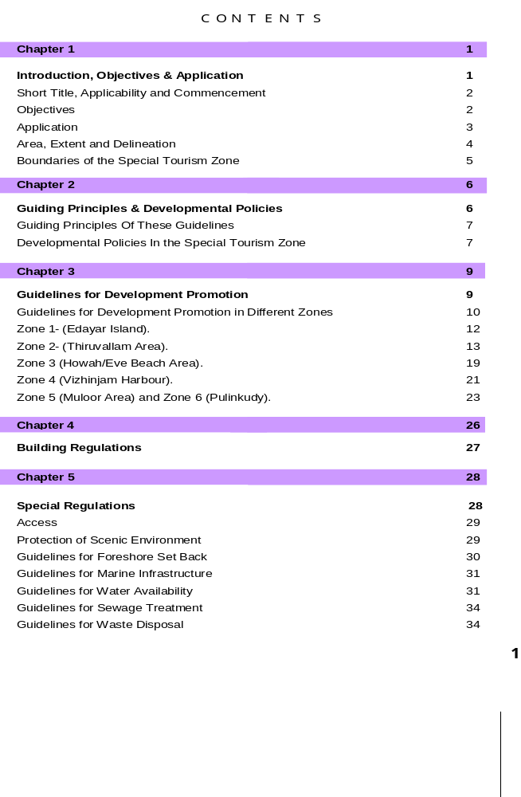

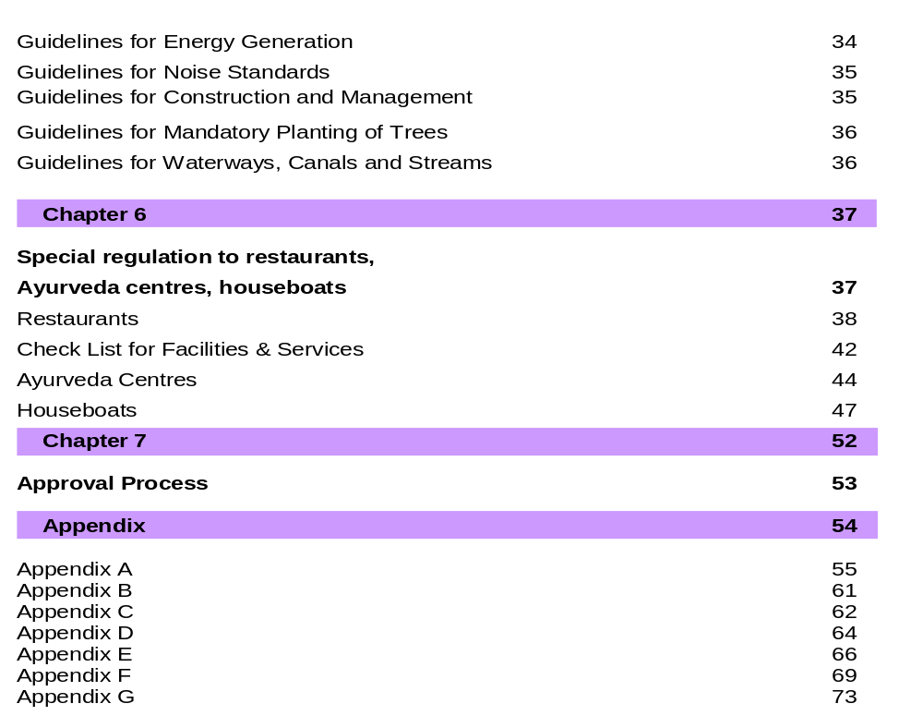

Preservation of Special Tourism Zone- Kovalam as per the Kerala Tourism (Conservation and Preservation of Areas) Ordinance, 2005.

